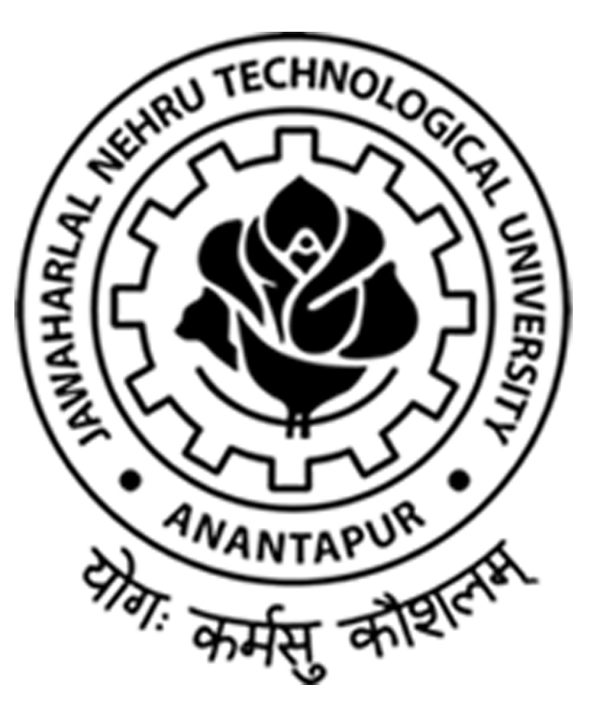

**JAWAHARLAL NEHRU TECHNOLOGICAL UNIVERSITY ANANTAPUR**

**ANANTHAPURAMU-515 002, ANDHRA PRADESH, INDIA**

**ELEVENTH CONVOCATION**

**24th April, 2021**

**Address**

**by**

**Prof. Anil D. Sahasrabudhe**

**Chairman,**

**All India Council for Technical Education (AICTE),**

**New Delhi.**

Honorable Governor of Andhra Pradesh and Chancellor of JNTU, Ananthpur Shri Biswabhushan Harichandran, Hon’ble Minister for Education of Government of Andhra Pradesh and Guest of Honour Dr. Adimulupu Suresh, the Recipient of Honoris Causa Prof Y. Vankatarami Reddy, Former Member, UPSC, New Delhi, Vice Chancellor of JNTUA, Prof. G. Ranga Janardhana, Registrar, JNTUA, Prof. M. Vijay Kumar, Directors, Principals, HoDs, Members of the Executive Council as well as members of Academic Council of JNTUA, Faculty and staff of the University, Graduating Students of JNTUA and their parents, all special invitees for today’s function, members of media, ladies and gentlemen.

I wish to thank you all for inviting me to participate in this joyous occasion of the eleventh convocation of JNTUA Ananthapuramu being held in this great university. I also join others in congratulating all the graduating students as well as their teachers and parents. The convocation is a defining moment in one’s life. On such an occasion I wish to share some of my thoughts with the graduating students.

History of JNTUA is interesting. Started as a College of Engineering in1946, before independence in Guindy College of Engineering, moving to Ananthpur in 1948 and became full fledged state university in 1972. It has to its credits some of the prominent alumni who have contributed to the advancement of Science and Technology in India and abroad. It stands within top 200 ranks in NIRF and programmes are accredited by NBA. There have been large number of research projects undertaken funded by various government agencies.

Dear graduates,

Honorable Prime Minister often places emphasis on the youth of India and their potential in the same manner as that of Swami Vivekananda, who had said that give me 100 motivated and committed young men and I will change the face of India. Swamiji also believed in competence in every individual. That is why he often used to say education is manifestation of perfection already in man. That perfection has only to be brought out, honed, mentored and made available for the development of the nation. The Honourable Prime Minister Modi also speaks the same language. Transformation of India, into a Digital India, a nation which is clean, environment friendly, uses as much renewable energy as possible, turn around cities and villages into smart cities, and smart villages, empowered and entrepreneurial with emphasis on Make in India and Atmanirbhar Bharat. The glimpses of these ideas are visible. India has done extremely well in the field of science and technology in recent past. India is one of the rarest of nations who managed COVID19 crisis better than any other nation in the world. From hardly any capacity of testing kits, PPE kits and ventilators to exporting these and the newly developed vaccines to several nations India has shown the world our ancient culture of Vasudhaiva Kutumbakam and Sarve Janaha Sukhinou Bhavantu. Even highly developed countries are looking towards India, for the vaccines.

The Government of India had started an indigenous MOOC platform SWAYAM and large number of courses were already available. The universities and colleges started not only use of these SWAYAM courses, but their own online education too at all levels –School. College and University level. Even with very limited resources, online teaching learning mode was adopted in our country in a very short span of time. This adoption was majorly possible due to enormous zeal, passion and energy of the youth of our country and brain power of our technocrats.

Our country has recently announced the **National Education Policy 2020(NEP-2020),** which was approved by the Union Cabinet of India on **29th July 2020** outlining the vision of India’s new education system. The new policy replaces the previous National policy on Education 1986. The policy is a comprehensive framework for elementary to higher education as well as vocational training in both rural and urban India. The policy aims to transform India’s education eco system in a big way. Education in India is a Concurrent List subject. National Education Policy 2020 envisions an India centric education system that contributes directly to transforming our nation sustainably in to an equitable and vibrant knowledge society by providing high quality education to all. The mantra of access, equity, quality is expanded to include affordability, accountability, autonomy and accreditation. There is emphasis on multidisciplinary university, research intensive and teaching intensive universities, multiple exits with certificates or Diplomas, re-entry later, academic bank of credits etc. There is support for innovation and research in a big way through National Research Foundation. The emphasis on teacher education is crucial.

The Indian economy was in its worst phase even before the corona virus outbreak, with growth in the Gross Domestic Product (GDP) falling to 11 year low of 4.2% in 2019-2020. The Indian economy is already on the upswing, the IMF has indicated that India’s growth projection is going to be 11.5% in 2021.

Dear graduating students, India is on the rise. Gone are the days, when we used to see opportunities abroad both for higher studies and good jobs. The Centre of Gravity is shifting to India. Study in India, startup eco system, growing economy, all of this along with vision of our PM, be it Swaccha Bharat, Skill India, Digital India, Smart Cities, Unnat Bharat Abhiyan, Make in India, Startup India, Atmanirbhar Bharat, are providing you great opportunities. The education that you have got from JNTU, values that you have imbibed here will go a long way to not only take care of your own families, state and nation, but you have all the potential to help the whole world. There are certainly challenges ahead, but these challenges need to be converted into opportunities, put in your best efforts, hard work, passion and commitment and you are bound to succeed. Set a vision for yourself and that for your state and nation and pursue it with all seriousness.

All the graduating students---Now you are moving out to the real world. Go forward with a positive mindset and explore it. Never extinguish your thirst for knowledge. Refine yourselves as better human beings and as socially responsible citizens. Now you have to contribute back to the society which has nurtured and nourished you. Be the global citizens and work for making this world a better place. You are all going to be the proud ambassadors of **JNTU Ananthpur**. From today onwards you are joining the distinguished alumni group of this University – Always keep in touch with your Almamater and try to live a life which would make your Almamater proud of you.

I consider myself fortunate to be the part of this ceremony and would like to express my best wishes to all of you. With these words I wish you all a highly fruitful career and a blissful life ahead. Thank you.

# *JAI HIND!!!!!*