JNTUA SMS :: FACULTY DEVELOPMENT PROGRAMME REPORT

Online one-week Faculty Development Program
“Application of Emerging Technologies in Business”
Sponsored by
Faculty Development Cell, AICTE under Technical Teachers Training Scheme of AICTE
Organised by
JNTUA School of Management Studies &
Directorate of Faculty Development & IQAC, JNTUA, Ananthapuramu

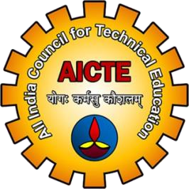
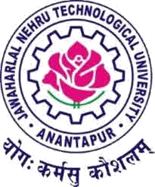

INAUGURAL FUNCTION
OF
One Week Faculty Development Programme
On

“Application of Emerging Technologies in Business”
(07th December – 12th December, 2020)
Faculty Development Cell, AICTE under Technical Teachers Training Scheme of AICTE
Organized by
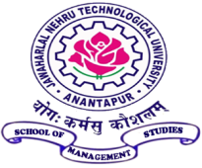
JNTUA School of Management Studies
JAWAHARLAL NEHRU TECHNOLOGICAL UNIVERSITY ANANTAPUR
ANANTHAPURAMU-515002
&
Directorate of Faculty Development & IQAC, JNTUA, Ananthapuramu

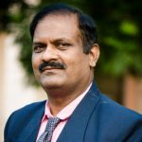
–––
Chief Guest
Prof.B.Rajasekhar
PVC-2, University Of Hyderabad

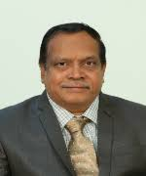
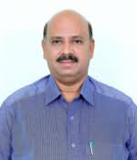
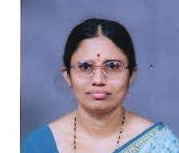
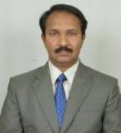

Course Coordinator
Prof.M.L.S.Deva Kumar
Director, JNTUASMS
JNTUA
University Coordinator
Prof.G.Prasanthi
Director, Faculty Development & IQAC
JNTUA
Registrar
Prof.M.Vijaya Kumar
Registrar
JNTUA
Guest of Honour
Prof.S.Srinivas Kumar
Vice Chancellor
JNTUA

LIST OF RESOURCE PERSONS
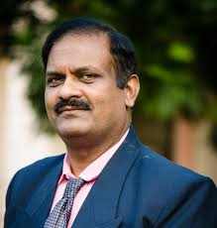
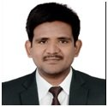
Prof. B. Raja Shekhar,
Pro Vice Chancellor-2,
University of Hyderabad

Dr. Suresh Kandulapti
TEKsystems Global Services
Hyderabad

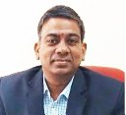
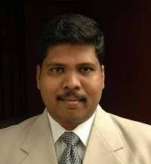
Dr. DV. Srinivasa Kumar
University of Hyderabad

Dr. Irala L. Reddy
University of Hyderabad

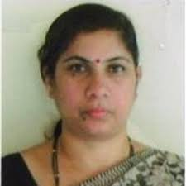
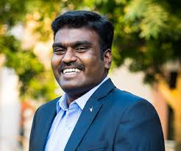
Dr. M. Akkalakshmi
Vice Principal,
GITAM University Hyderabad

Dr.P. Murugan
University of Hyderabad

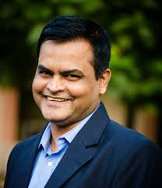

Mr. Prasanth Sahoo, TCS

Dr. Pramod Kumar Mishra
University of Hyderabad

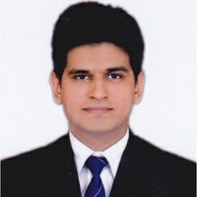
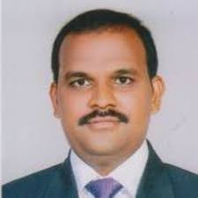
Intisar Mehdi
Synchronism Solutions

Dr. E. Suresh Babu
NIT Warangal

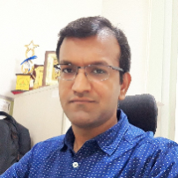
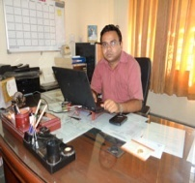

Dr. Mayank Agarwal,
GKV, Haridwar

Dr. Anshuman Kalla
University of Oulu,
Finland

Faculty Development Cell, AICTE under Technical Teachers Training Scheme of AICTE
Sponsored Online One-Week Online Faculty Development Program on
“Application of Emerging Technologies in Business” conducted by the JNTUA School of Management Studies, Jawaharlal Nehru Technological University Anantapur, Ananthapuramu – 515002.
(07-12-2020 to 12-12-2020)
SCHEDULE OF THE PROGRAM

Time | 10 – 11:30am | 11.45 - 01.15pm | L  u n c h  B  r e a k | 02.15 -3.45 pm | 4- 5.30 pm
Date & Day
07-12-2020  Monday | Inauguration of the FDP | Big Data  Dr. Suresh Kandulapati, TEKsystems Global Services, Hyderabad |  | Introduction to Data Science & Business Analytics  Prof. B Raja Shekhar,PVC-2,  University of Hyderabad | Spreadsheet Modelling  Dr. Irala L. Reddy  University of Hyderabad
08-12-2020  Tuesday | Introduction to Marketing Analytics (& Demonstration of business cases)  Dr. DV. Srinivasa Kumar  University of Hyderabad | Introduction to R- Programming  Dr. DV. Srinivasa Kumar  University of Hyderabad |  | Introduction to HR Analytics (& Demonstration of business cases)  Dr. P. Murugan  University of Hyderabad | Introduction to Financial Analytics (& Demonstration of business cases)  Dr. Irala L. Reddy  University of Hyderabad
09-12-2020  Wednesday | Data Visualization-I  Dr. M. Akkalakshmi  Vice Principal, GITAM University, HYDERABAD | Introduction to Supply Chain Analytics  (& Demonstration of business cases)  Dr. Pramod Kumar Mishra University of Hyderabad |  | Data Visualization-II  Dr. M. Akkalakshmi  Vice Principal, GITAM University, HYDERABAD | Multivariate Techniques for Data Analysis  Prof. B Raja Shekhar, PVC-2, University of Hyderabad
10-12-2020  Thursday | Introduction to Blockchain Technology and Properties of it.  Mr. Prasanth Sahoo, TCS | Cryptographic Primitives in Blockchain Network  Dr. E.Suresh Babu  NIT Warangal |  | Introduction to Solidity and IDE  Layout of source file Structure of Contract Create own Smart contract  Intisar Mehdi  Synchronism Solutions | Cryptocurrency in Ethereum  Editor and tools Ethereum Test Network  Intisar Mehdi  Synchronism Solutions
11-12-2020  Friday | Future of Cryptocurrency Mr. Prasanth Sahoo, TCS | Blockchain Ecosystem Dr. Anshuman Kalla  Manipal University, Jaipur |  | Hands On Experience with Remix  /Meta mask to build Smart Contract in Ethereum  Dr. Mayank Agarwal, GKV, Haridwar | Hands On with Building a Decentralized Application Dr. Mayank Agarwal, GKV, Haridwar
12-12-2020  Saturday | Applications of the Blockchain Technology  Mr. Prasanth Sahoo, TCS | Permissioned Blockchain Network using Hypereldger Fabric  Dr. E.Suresh Babu NIT Warangal |  | Use of Blockchain to Fight Against COVID-19  Dr. Anshuman Kalla Manipal University, Jaipur | Final Test & Feed back

The faculty development programme started with inaugural function by the guest of honour Prof. M. L. S DEVA KUMAR GAARU AND Chief Guest Professor B .Raja Shekhar ,Pro Vice Chancellor, University of Hyderabad.

The first session was by the Suresh Kandulapati on Big data its evolution, characteristics, business drivers, what is the need of the big data and concept of big data analytics, scope, challenges, tools and skill set of big data analytics.

The second session was by the Prof. Dr. B Raja Sekhar gaaru on the topic introduction to data science and business analytics. In this session the speaker explained about the introduction and life cycle of the data science. Later the speaker spoken about the business analytics its applications , types and various challenges faced due to business analytics.
The first day final session was by the Prof. Irala Lokanathareddy Gaaru on the topic ms excel and usage of various functions and formulas such as MAX, IF CONDITIONAL, VLOOKUP, CONDITIONAL FORMATTING, COUNTIFS, CONCAT, PIVOT TABLE , PIVOT CHART. These functions are used to compute the result of huge volume of data which resolves the issues on time. And data representation using pivot charts.
The second day of the has been laid by the DR. D V SRINIVAS KUMAR GAARU, on the topic marketing analytics and topics related to market segmentation includes bases such as demographic, psychograpic, behavioural and geographical. And various concepts include conjoint analysis, perpetual mapping,campaign budgeting, customer life time value, survival analysis, Market based analysis, digital marketing, online text analysis and AI driven by marketing.
The session continued with the same speaker on the topic R Programming which is a statistical programming language. In this session the topics dealt by the speaker is introduction to R, How R works its need, Packages in R, Installation of R and R studio and various concepts include data structures and its use in rstudio in detail.
The next session was by Dr. P. MURUGAN on the topic INRODUCTION TO HR ANALYTICS AND DEMONSTRATION OF BUSINESS CASES. Later the speaker discussed about the various types of analytics and comparision of HR METRICS AND HR ANALYTICS.
The second day final session was by the Prof. Irala Lokanathareddy Gaaru on the topic financial analytics and discussed concepts relating to the analytics, introduction to finance, areas of finance and use of analytics in financial services. Concepts of ratios and about various types of ratios in financial management. Other concepts using predictictive analytics i.e., shareholder analysis, stock price estimation and cash budgeting.
The third day of the session was started by the PROF. DR. M. AKKA LAKSHMI on the topic data visualisation firstly dealt concepts are data, information and data visualisation tools. And python libraries and installing matpoint library.
The next session is followed by Dr. Pramod Kumar Mishra on the topic introduction to supply chain analysis and demonstration of business cases. In this session the main concepts discussed are supply chain analysis models various supply chain decisions such as location, production, inventory and transportation decisions. Later the speaker discussed about practical case of supply chain analysis and how to write a business case.
The afternoon session of third day is by the Prof. DR. M. AKKA LAKSHMI on the topic Business case resources the concepts include construction of smart sheets. And use of various functions such as pairplot, scatterplot, regression line, charts and maps.
The final session of the third day by the Prof. Dr.B RAJA SEKHAR GAARU on the topic multivariate techniques for data analysis. In this session the various techniques used for data analysis are discussed using metric and non metric variables. And solving of Simpsons paradox using chi-square test.. later the speaker discussed about classification of multivariate methods. Finally discussed abou the cluster analysis using practical case.

The fourth day of the session was started by Prof. Prasanth Sahoo on the topic Introduction to Block Chain. The speaker started the session like in this programme we have learning out various technologies such as Big data, AI, IoT, Blockchain technology. At present, the fourth industrial revolution is going out so it is all about technologies like AI, Quantum Computing. Later, the speaker spoken about Block Chain architecture, what is blockchain and various algorithms used in blockchain in order to be in more secure such as SHA256 etc..
The followed session on the fourth day was continued by Prof. E. Suresh Babu Garu on Block Chain Eco-System. The various concepts dealt in this session are as follows,
- Trends & Technology
- Landmark Technology Advances
- Issue with Traditional Centralized System
- Trend:Centralized to Decentralized
- Introduction to Block Chain
- Four Key Concepts of Blockchain and Model of Blockchain

The After noon session was continued by Intisar Mehdi Garu. On the topic of Smart Contract, Block Chain,Smart Contract on Block Chain, How to write Smart Contract with examples, Later the speaker explained about how to write smart contract using solidity with the help of remix compiler. Making of transactions using meta mask a chrome based extension using creation of ethers with the help of faucets and ethers.

The fifth day of the session was started by Prasanth Sahoo on the topic of future crypto currencies. The speaker spoken about the crypto currencies and its various types and mainly concentrated on Bitcoin and its future outlook. Also discuss about the various crypto currencies such ripple,lite coin etc

The next session followed by Anshuman Kalla on the topic Block chain and Smart Contracts.In this session the speaker discussed about various types of block chains and its characteristics. And its applications in the real time scenario.

After noon session of the 5th day was continued by Dr. Mayank Agarwal. In this session the speaker explained about web 2.0 and revolutionary change which we are using currently i.e. web 3.0. And the concepts about the pro-privacy, anti-monopoly web . Later also Discussed about Block chain and its types , Ethereum platform and use of solidity.

The Sixth day of session started by Mr. Prasanth Sahoo. In this session he discussed about ethereum and smart contracts and writing of smart contracts using solidity.
The followed session was discussed by Dr. E. Suresh Babu Permissioned Blockchain Network using Hyper Ledger Fabric. In this session he discussed about Introduction to Hyper ledger , Hyper ledger fabric and its transaction flow.
The afternoon session of Last day FDP was followed by Dr. Anshuman Kalla on the topic “USE OF BLOCKCHAIN TO FIGHT AGAINST COVID19” using various case scenarios and steps.
The valedictory function of AICTE sponsored one week online faculty development programme APPLICATION OF EMERGING TECHONOLOGIES IN BUSINESS organized by JNTUA school of Management studies, Ananthapuram &Directorate of Faculty Development & IQAC, JNTUA was started by welcome address of DR. D. Varalakshmi. She welcomed the chief guest ,the honorable vice chancellor of Rayalaseema university and I/C Vice chancellor JNTUA, Ananthapuram Prof. A. Ananda Rao, Guest of honor Prof . M. Vijaya Kumar , Registrar ,JNTUA, University coordinator and Director , Faculty Development & IQAC, JNTUA Prof. Prashanthi , program coordinator Prof. M.L.S Deva Kumar Director, JNTUA SMS JNTUA , resource persons, participant and the faculty for the valedictory function and requested program coordinator Prof. M.L.S Deva Kumar Director, JNTUA SMS JNTUA to give closing report of the program.

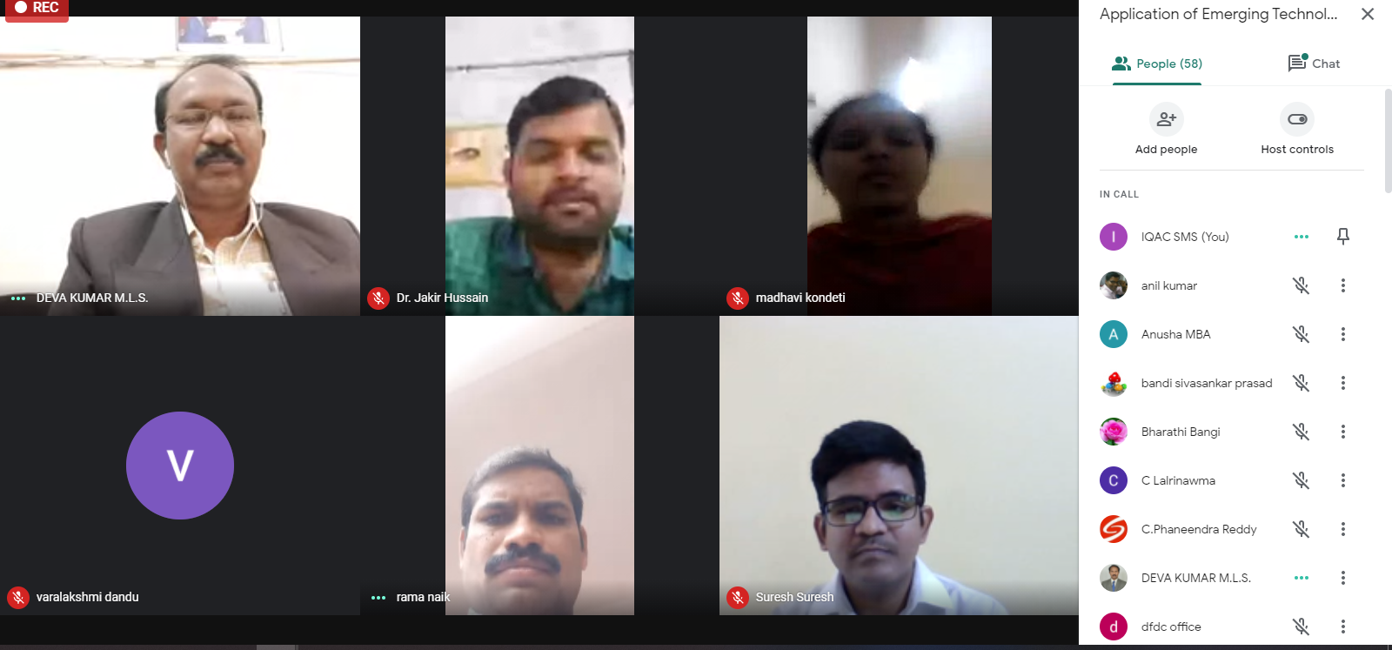

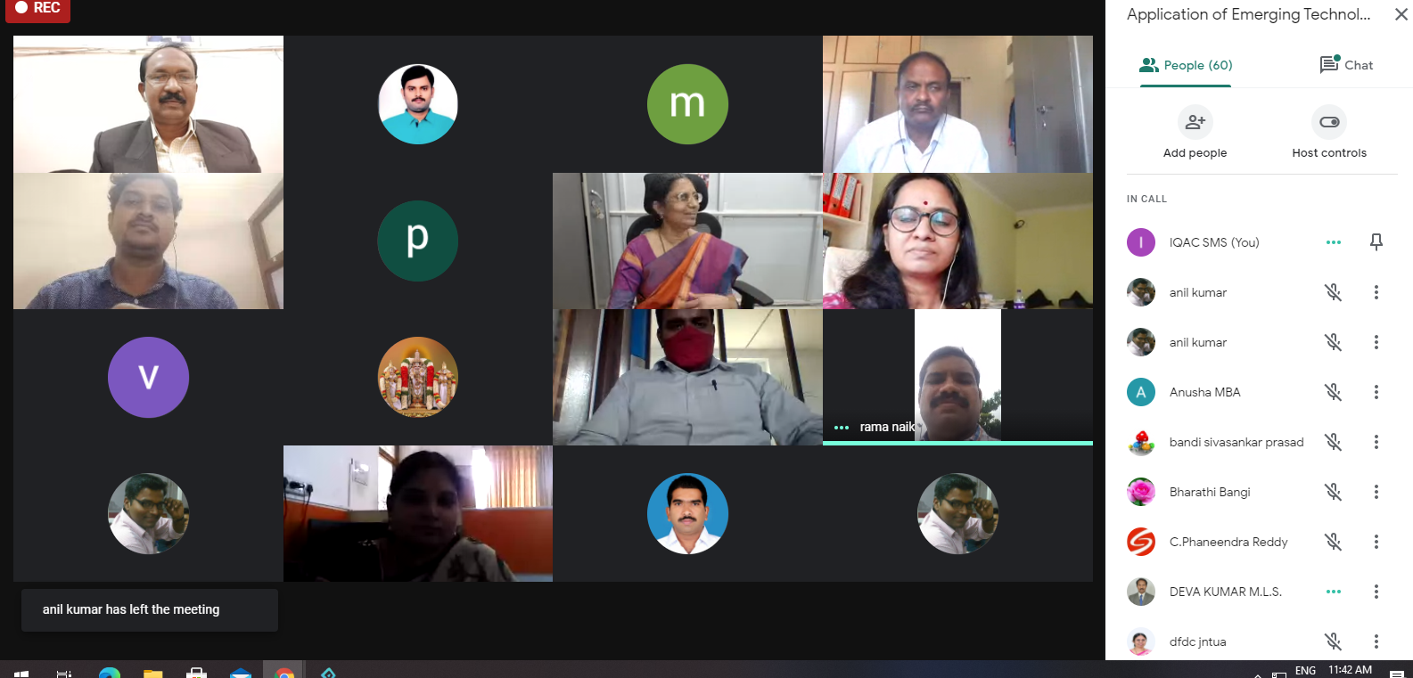

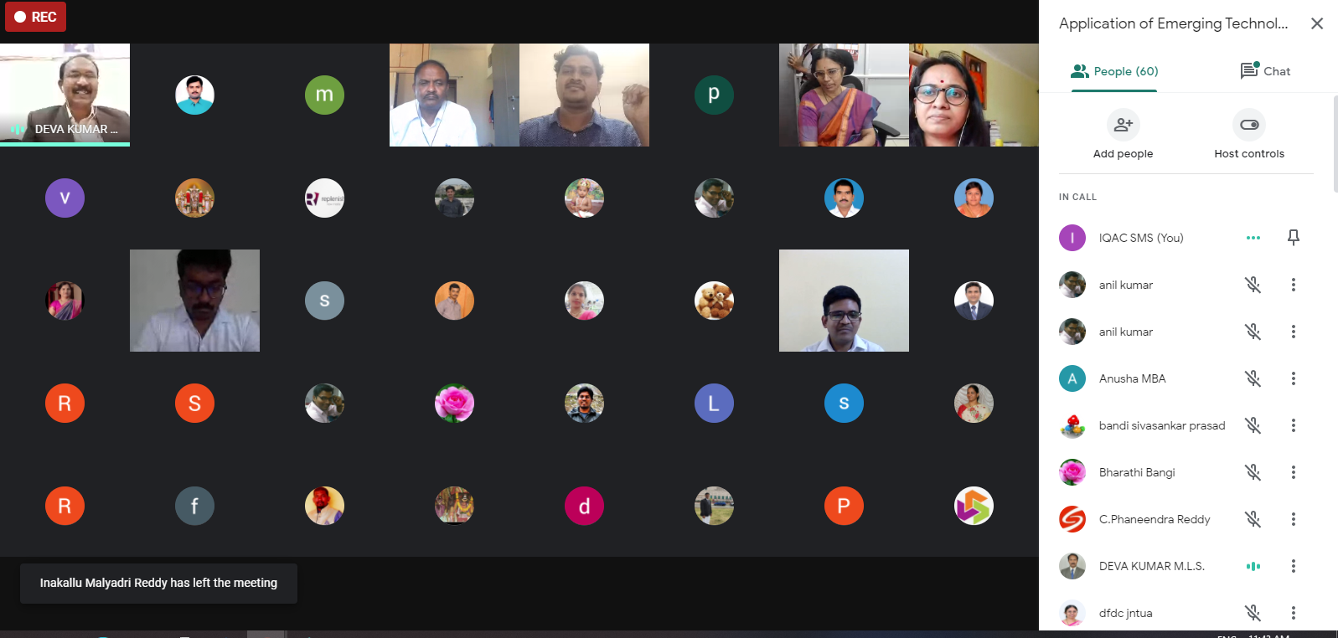

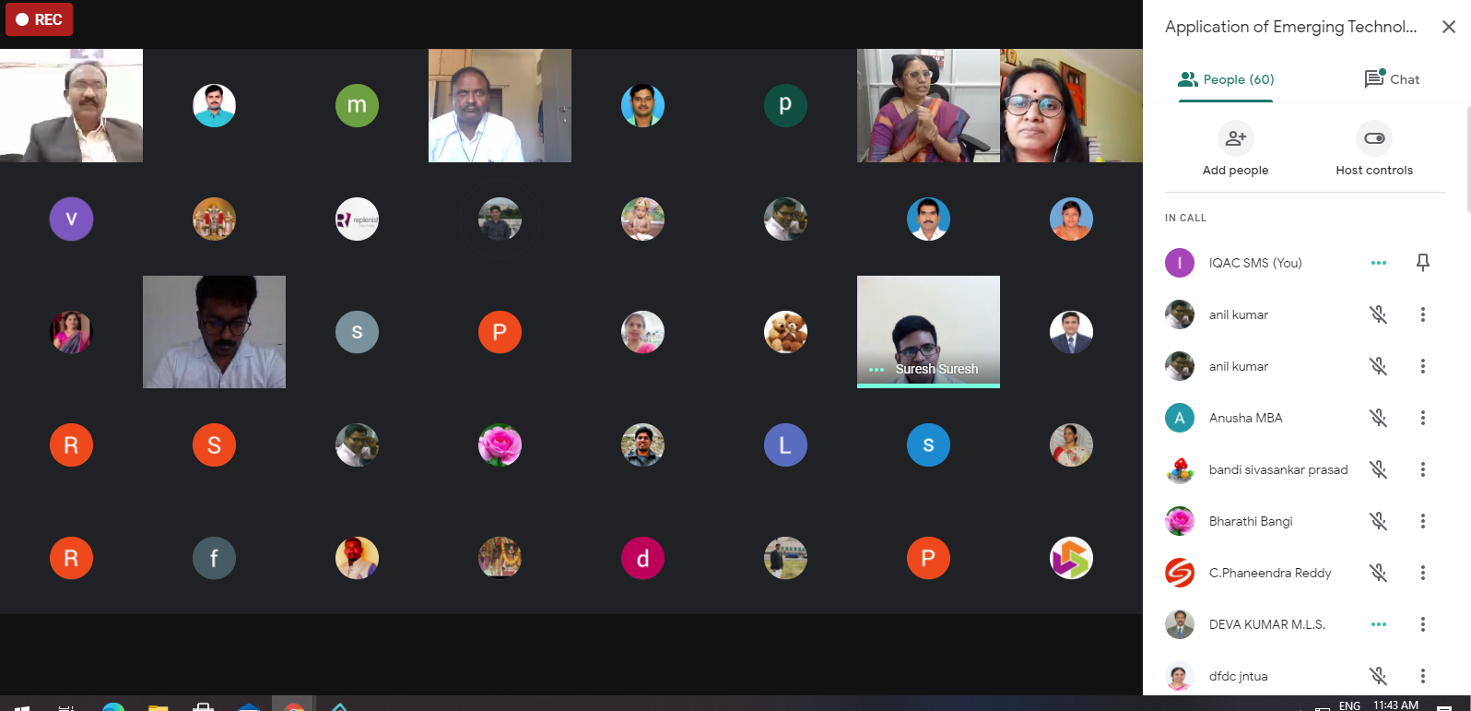

MEDIA REPORTS

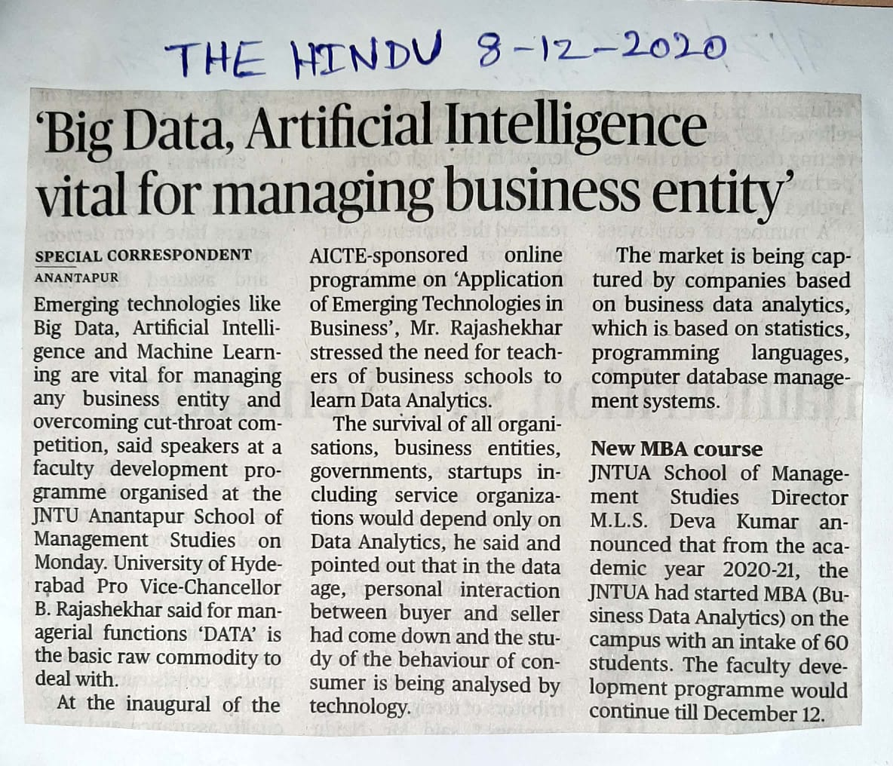

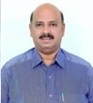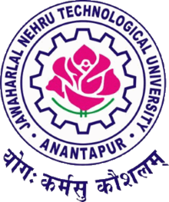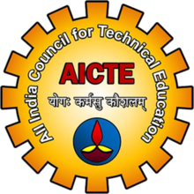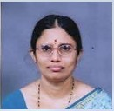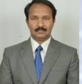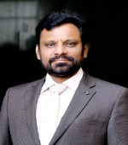
VALEDICTORY FUNCTION OF
One Week Faculty Development Programme On
“Application of Emerging Technologies in Business”
(07th December – 12th December, 2020)
Sponsored by

Faculty Development Cell, AICTE under Technical Teachers Training Scheme of AICTE
Organized by

JNTUA School of Management Studies
JAWAHARLAL NEHRU TECHNOLOGICAL UNIVERSITY ANANTAPUR ANANTHAPURAMU-515002
&
Directorate of Faculty Development & IQAC, JNTUA, Ananthapuramu

University Coordinator
Prof.M.L.S.Deva Kumar
Director, JNTUA SMS
JNTUA

University Coordinator
Prof.G.Prasanthi
Director, Faculty
Development & IQAC,JNTUA

Guest Of Honor
Prof.M.Vijaya Kumar
Registrar
JNTUA,Ananthapuram

Chief Guest
Prof.A.Ananda Rao i/c .Vice Chancellor
JNTUA,Ananthapuram

Valedictory speech on One Week Online Faculty Development Programme on
APPLICATION OF EMERGING TECHONOLOGIES IN BUSINESS
From 7th to 12thDecember, 2020
Organized by
JNTUA School of Management Studies, Ananthapuramu &
Directorate of Faculty Development & IQAC, JNTUA

The valedictory function of AICTE sponsored one week online faculty development programme APPLICATION OF EMERGING TECHONOLOGIES IN BUSINESS organized by JNTUA school of Management studies, Ananthapuram &Directorate of Faculty Development & IQAC, JNTUA was started by welcome address of DR. D. Varalakshmi. She welcomed the chief guest ,the honorable vice chancellor of Rayalaseema university and I/C Vice chancellor JNTUA, Ananthapuram Prof. A. Ananda Rao, Guest of honor Prof . M. Vijaya Kumar , Registrar ,JNTUA, University coordinator and Director , Faculty Development & IQAC, JNTUA Prof. Prashanthi , program coordinator Prof. M.L.S Deva Kumar Director, JNTUA SMS JNTUA , resource persons, participant and the faculty for the valedictory function and requested program coordinator Prof. M.L.S Deva Kumar Director, JNTUA SMS JNTUA to give closing report of the program.

Program coordinator Prof. M.L.S Deva Kumar Director, JNTUA SMS JNTUA , has delivered the closing report by welcoming chief guests , participants and resource persons. He also extended his gratitude to organizers and and the participants from different institutions for making the programme fruitful. In the report he mentioned the topics covered by the resource persons as per the topic application of emerging technologies in business. The topics covered in the program by the speakers as follows.

An enlightening session by Prof. Rajashekar about an introduction to the data science and business analytics and need and adaptation of technologies for the business helps the personnel to get trained and meet the industrial needs.
A session by Dr. Lokanadha Reddy about the introduction to the spreadsheet modeling , which is widely using in business shares the information ,that how to predict the future outcome in the business and financial analytics with the business cases given the practical insights.

Marketing analytics and introduction to R – programming by Dr. Srinivas Kumar given information regarding statistical computing that plays major role in marketing business.
Human resource analytics session by Dr. Murugappa explained how industry is witnessing the advent of major fields like Big data and hiring analytics that is beneficial in talent acquisition, marketing etc…

Resourceful session by Dr.Astalakshmi regarding block chain technology, data visualization with the practical examples helped the management students to understand the concept in the better way.
An introduction to the supply chain management and analytics by Pramod Kumar Mishra helps to better understanding of the concepts that keeps the business at pace.
Emerging technologies like block chain, crypto primitives and block chain networks by Dr. Suresh babu had enlighten the concepts in easy way to understand .
Future of crypto currency by Prashant sahu given more insights about this concept that that is gaining ground helps to bridge the gaps and have versatile applications of the industry.
Concepts on big data by Dr. Suresh babu explains its importance in how companies use the big data analytics to figure out the most valuable customers and also helps businesses create new experiences, services and products.

Mr. Anshuman kalla given the great lecture about block chain ecosystem that helps to fight the current pandemic Covid-19 situation. An overview of data structures, data analytics, data science, cryptography and its applications in business helps the faculty to understand the concepts thoroughly.

FEEDBACK BY PARTICIPANTS:
Most participants felt that the correct direction and knowledge for conducting scientific research was obtained in the workshop
Thank you very much for an engaging and motivating for few days. The workshop was well- structured, insightful and rich in contentthat enlightened me the usage of emerging technologies in business – Gnanaprasuna from SEC college Tirupathi
The workshop helped me to identify area of research which I wouldn't have looked at before. Also helped me to ignite my own thought process. Dr. Balakoteswari from sankriti school lof business puttaparthi

The FDP program introduced the new concepts that were helpful for the management study students and also appreciated the organizers for conducting the programme in timely manner.- Sunil Kumar
Thalari Sanjeev kumar congratulated the organizers for the selection of the interesting topic. He also greeted and appreciated each and every person who were the part of this program.
Dr. R. Vani from Narayana engineering college , Nellore said this program helped her improving skills by participating in this excited Faculty Development Programme.

University coordinator and Director Faculty Development & IQAC, JNTUA Prof. Prashanthi ,addresses the participants regarding the FDP program and also congratulatedthe resource persons and the program organizers . She explained how JNTU Ananthapuram got tied up with the AICTE for conducting and sponsoring the FDP. She felt happy for the feedback given by the participants and also felt delightful by topics that covered in the programme like block chain technology and data visualization etc... She also extended her gratitude towards the resource persons for providing the hands-on training with the live examples. She also congratulated the organizers for the program curriculum and arranging the versatile national and international speakers.
Due to the unavoidable reasons Guest of honor Prof . M.Vijaya Kumar , Registrar ,JNTUA was not able to join the valedictory function.

Dr. Paruchuru Vishwanath given the brief introduction about the chief guest honorable vice chancellor of Rayalaseema university and I/C Vice chancellor JNTUA, Ananthapuram Prof. A. Ananda Rao

Prof. A. Ananda Rao addressed the function by congratulated the program coordinator Prof. M.L.S Devakumar and his team for making the program grand success. He also felt grateful for the topics covered in the programme which is the need of the day. He also appreciated for conducting the online FDP. He also given insights for application of cross functional technologies to the user department to produce greater results. He also suggested the participants to practice more the concerned topics in order get more knowledge that helps to share to the students. He concluded his speech by whishing the participants and congratulating Dr. D .VaraLakshmi for organizing the program in the disciplined program.
Outcomes:
The Faculty Development Programme (FDP) fulfils its prime objectives to bring the faculties of cross functional departments on to one platform to update with the advances in the technologies in the business and applications, effective teaching learning practices.All the sessions were very informative. The role of faculty in creativity-based learning was demonstrated. Activity based learning methods demonstrated, so that participants can implement the same in their institutes. A detailed discussions and practical sessions held on Outcome Based Education, so that the participants can adopt the same for quality improvement of their respective institutions. Last but not least when the house was open for discussion, the participants were keen to ask and with the same level of enthusiasm they were justifiably answered by the expert speakers. The FDP not only helped the participants in their curriculum development, teaching methodology but also helped them to know evaluation tools.
We are thankful to the enthusiastic participants, speakers, who attended the programme. We are also thankful to AICTE for sanctioning the fund to organize programme. We extend our thanks to Dr. D Varalakshmi, Co- Coordinator, Teaching and Non-teaching staff who helped us to make this event a grand success.
The vote of thanks was given by Dr.D Vralaksmi, FDP Co-coordinator. she highlighted the immense contribution of the Organizing Committee members and experts. she presented a special thanks to patron of program and the I/C Vice chancellor JNTUA Prof. A. Ananda Rao and also University coordinator and Director , Faculty Development & IQAC, JNTUA Prof. Prashanthi , program coordinator Prof.M.L.S Devakumar Drirector, JNTUA SMS JNTUA . She also shown her gratitude towards her colleagues for facilitating the event. she heartily thanked all the speakers who spared their valuable time for the program. she also thanked all the participants who made this event a grand success by participating wholeheartedly. The valedictory session ended with the national anthem.

