GuruCool - An IBM's unique initiative exclusive for Faculty
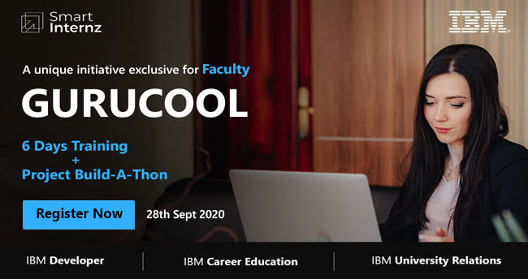
About GuruCool:
Most of the Industry-led programs are focussed on students, developer whereas Teachers are the ones who play the most pivotal role in shaping anyone's growth and India's future.

IBM in collaboration with Smartbridge invites all faculty members to participate in this month-long Training & Project Build-a-Thon program. This will help teachers to work on their best ideas with support from IBM and SmartBridge mentors. Learn, upskill, and collaborate to work on a project. There will be 6 days of technical workshops on technologies such as IoT, Python, Machine Learning, Cloud Native, Data Science, and Artificial Intelligence. Faculty members can attend technical sessions and enroll in the project(s) of their interest area. All workshops will be hands-on workshops and a free cloud account (lite) will be provided for learning and project building.

- Who can Apply? Any Faculty member, Any Stream

- Registration Fees? NIL | Last Date to Resister - 25th September 2020

- Registration Link - https://ibm.biz/GuruCool

- What’s in for Participants (for details, please refer the creative below and website)
    - Technical enablement through the hands-on workshops and Design Thinking workshop.
    - Free Access to IBM Cloud Lite Account
    - Free Access to IBM Academic initiative course ware and software
    - Earn Skills Badges - Free (digital certificates)
    - Dedicated mentoring over Slack and Industry connect
    - Exposure, Opportunity to start your Own Startup - IBM Startup Program
    - Prizes for Top projects under the individual technical project category and Top 3 Winner prizes under the overall program
    - Participation certificate from IBM
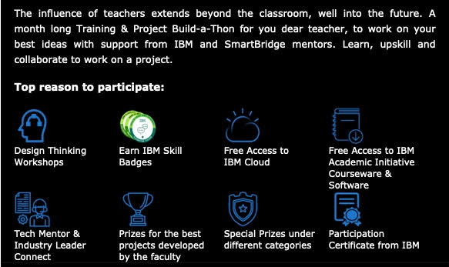

Interested Faculty members are informed to utilize this opportunity and build skills in emerging technologies.

Prof.V. Sumalatha
Director, Industrial Relations & Placements
JNTUA, Ananthapuramu

