JAWAHARLAL NEHRU TECHNOLOGICAL UNIVERSITY ANANTAPUR
IBM Off Campus Hiring process 2018 –
Global Business Services/Global Technology Services.

Details are as below:

Registration Link: https://goo.gl/2Hnwfu
Last date of Registration: 20-11-18

About IBM
IBM has been present in India since 1992. IBM India's solutions and services span all major industries including financial services, healthcare, government, automotive, telecommunications and education, among others. As a trusted partner with wide-ranging service capabilities, IBM helps clients transform and succeed in challenging circumstances. The diversity and breadth of the entire IBM portfolio of research, consulting, solutions, services, systems and software, uniquely distinguishes IBM India from other companies in the industry.

Global Business Services
Business Unit Introduction
IBM Global Business Services helps clients solve complex business and technical issues. We deliver innovative business consulting, process design, systems integration, application management and design. Our core competencies include deep business process and industry expertise, advanced analytics and research capabilities, comprehensive IT infrastructure knowledge, and proven ability to implement enterprise solutions that deliver bottom-line business value.
Academic Credentials/ Eligibility –
1.Course Completion Year: 2017/2018(Only candidates, who have completed & cleared their educational degree and have all Semester Mark sheets should apply)
2.Degree Courses: Graduation and Post-Graduation - B.E/ B.Tech/ M.E./ M.Tech – 65% or 6.5 CGPA.
SSLC / Xth, HSC / PUC / XII, Diploma or Equivalent - 60% or 6.0 CGPA. (Calculation of qualifying marks =
Sum total of marks obtained divided by Sum total of maximum marks obtainable. All subjects will be consideredincluding elective/optional subjects)
3. No current /past backlogs.

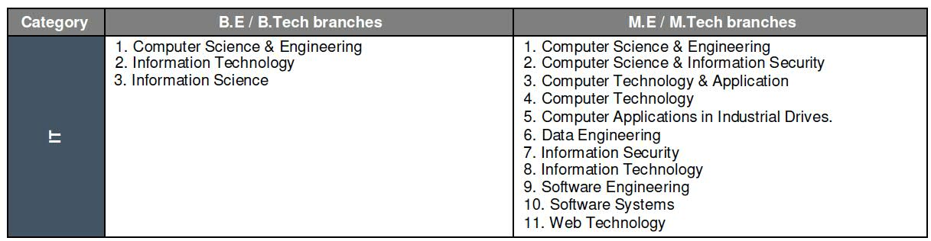
Who you are
This will be era of Man to the Power of Machine: not man versus machine, but man and machine. In addition to technological change, this new age requires us to change how we do our work.
IBM is the only Cloud platform that brings together infrastructure, software, services and Watson.
We are looking for like-minded engineers who bring fresh ideas from all areas like distributed computing, large-scale system design, networking and data storage, security, artificial intelligence, natural language processing, UI design and Mobile; the list is endless and we keep adding to it.
You will work on a specific project critical to IBM’s needs in a fast-paced business environment. We need our engineers to be versatile, showcase leadership qualities and be enthusiastic to tackle new problems across the full-stack as we continue to push technology forward.
What you'll do
- We are looking for exceptional candidates who are enterprising, have good interpersonal skills, can operate in large teams that work closely with clients across PAN India and are Flexible to work in all shifts.
- You must also have sound time management skills, ability to handle multiple tasks, prioritize and deliver
on time.
- Communicate (Written & Oral) effectively with stakeholders. Able to articulate with confidence the desired views.
- Passion to learn and apply technical prowess to solve Client problems.
- As new recruits, you will partner and network with the global IBM community while working alongside TopTalents.
The Global Delivery Centre is a challenging and an enriching platform to implement your academic learning in real time situations, acquire new skills and more importantly, help you to make a difference.
How we'll help you grow
• You’ll have access to all the technical and management training courses you need to become the expert you
want to be.
• You’ll learn directly from expert developers; our leaders love to mentor.
• You’ll have the opportunity to work in different areas to figure out what really excites you

Global Technology Services

Business Unit Introduction
At Global Technology Services (GTS), we help our clients envision the future by offering end-to-end IT and business process services, supported by an unmatched global delivery network. GTS builds standardized portfolios around key assets and patented software, and bundles them with best practices and proven methodologies to ensure high quality of delivery, security, and compliance. It's this unique blend of bold new ideas and client-first thinking that makes GTS the fastest-growing division of IBM
Who you are

This will be era of Man to the Power of Machine: not man versus machine, but man and machine. In addition to technological change, this new age requires us to change how we do our work.
IBM is the only Cloud platform that brings together infrastructure, software, services and Watson.
We are looking for like-minded engineers who bring fresh ideas from all areas like distributed computing, large-scale system design, networking and data storage, security, artificial intelligence, natural language processing, UI design and Mobile; the list is endless and we keep adding to it.

Academic Credentials/ Eligibility –
1.Course Completion Year: 2017/2018(Only candidates, who have completed & cleared their educational degree and have all Semester Mark sheets should apply)
2.Degree Courses: Graduation and Post-Graduation - B.E/ B.Tech/ MCA– 65% or 6.5 CGPA.(Calculation of qualifying marks =Sum total of marks obtained divided by Sum total of maximum marks obtainable. All subjects will be consideredincluding elective/optional subjects)
3. No current /past backlogs.

Category | B.E/B.Tech Branches | MCA
 | Computer Science Engineering / Computer Engineering | Master Of Computer Application
 | Information Science and Engineering / Information Technology
 | Electrical and Electronics Engineering
 | Electronics and Communication Engineering
This is an Off Campus hiring for an entry level position, and the candidates should have completed their final year of education and should have obtained their degree prior to start of employment with IBM.

Neither IBM India Pvt. Ltd. nor any of its subsidiaries (collectively 'IBM'), nor any authorized third party who assists with our recruitment process, ever ask candidates for 'recruitment', 'processing' or any other kind of fees in exchange for offer letters from IBM. Offer letters and other recruiting correspondence from IBM are sent from an official e-mail id and/or are printed on IBM letterhead with authentic signatures of appropriate IBM authorities.

Prof.V.Sumalatha
Director, Industrial Relations & Placements
JNTUA, Ananthapuramu.
Phone: 08554273007

