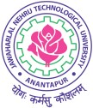
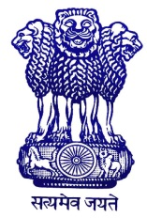
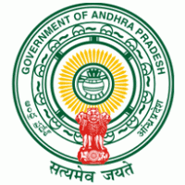

NATIONAL SERVICE SCHEME
ANDHRA PRADESH STATE LEVEL NSS YOUTH FESTIVAL – 2015
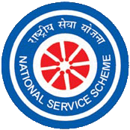

12 - 13 February, 2015
J.N.T.U. Anantapur , Ananthapuramu, Andhra Pradesh.
“ Culture is the widening of the mind and spirit “
-Jawaharlal Nehru
News Letter
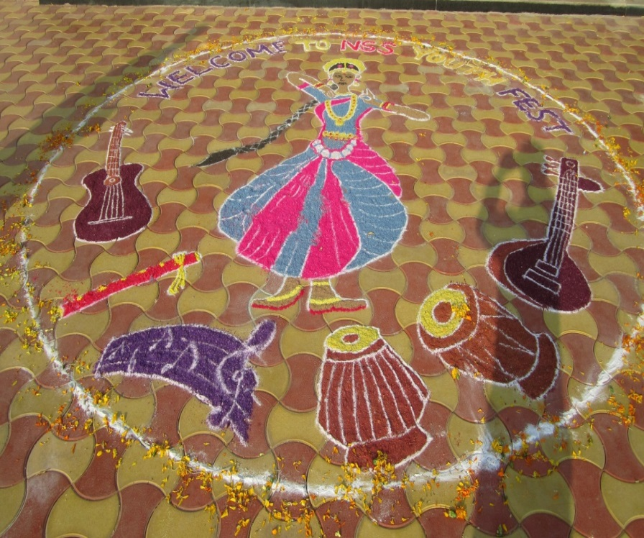
On 12-13th February 2015, the NSS Cell, Jawaharlal Nehru Technological University Anantapur, Ananthapuramu organised the State Level NSS Youth Festival at JNTU Anantapur. On 12th morning the Youth Festival started with a Rally flagged off by Honourable Vice-Chancellor JNTUA Prof.K.Lal Kishore and Sri.R.Gokula Krishanan Youth Ofiicer and Head, Regional Centre, Govt. of India, Hyderabad, Sri.P.Ramachandra Rao A.P.NSS State Liasion Officer in the presence of Prof. H.Sudarsana Rao Rector, JNTUA, Prof. S.Krishanaiah Registrar JNTUA, Prof. M.L.S.Deva Kumar NSS Programme Coordinator, JNTUA, Dr.M.S.N.Reddy Telangana State NSS Liason Officer, Directors of JNTUA, Dr.N.A.D.Pal Training Coordinator, UTOC, Visakapatnam etc., The rally lead by the NSS Volunteers of the host University performing various traditional programmes followed by the participants from different Universities from all over the state of Andhra Pradesh. The Rally continued for about 1 k.m and ended at J.N.T.U.A.College of Engineering Main Building, where Inaugural function was commenced. Later the Youth Festival was set open with ‘Jyothi Prazwalana’. On afternoon, competitive events like Elocution, Essay Writing, Debate, Poster Painting, Solo Singing, Solo Instrumental and Patriotic Poem. They were concluded by the evening and then began the Cultural Competitions both Solo Dance (classical) and Group Dance (folk). After dinner ‘camp fire’ was lit at the University Auditorium. Next day remaining events like Quiz, Rangoli, Photo exhibition were conducted followed by an intellectual sessions – SUVICHAAR is organised, where eminent personalities of various fields spoke about social issues relevant to the present youth. The Youth festival was closed with a valedictory which involved prize distribution to the winners. The detailed report of the Youth Festival is presented below.
Inaugural Rally and Function

The rally started from University Auditorium and passed through the main road. Throughout the rally, traditional ethnic programmes like ‘Kolatam’, ‘Chekka Bhajana’, ‘Karrasamu’ ‘Tacha’ ‘Dappu’ etc., have been performed by the students of the host University and all participating Universities. In addition to these the participants from other Universities gave their individual arty performance which added much grace to the rally. Several volunteers masquerading personalities like Jawaharlal Nehru, Swami Vivekananda, Bharatha Matha, Jhansi Lakshmi Bai, Lord Sri Krishna, Sri Krishanadevaraya was special attraction. Finally rally concluded at main building auditorium. After the rally, the programme continued with the inaugural function. The function was presided by Prof. S.Krishnaiah, Registrar of the J.N.T.University Anantapur. Honourable Vice-Chancellor, Prof. K.Lal Kishore attended as Chief Guest of the programme.

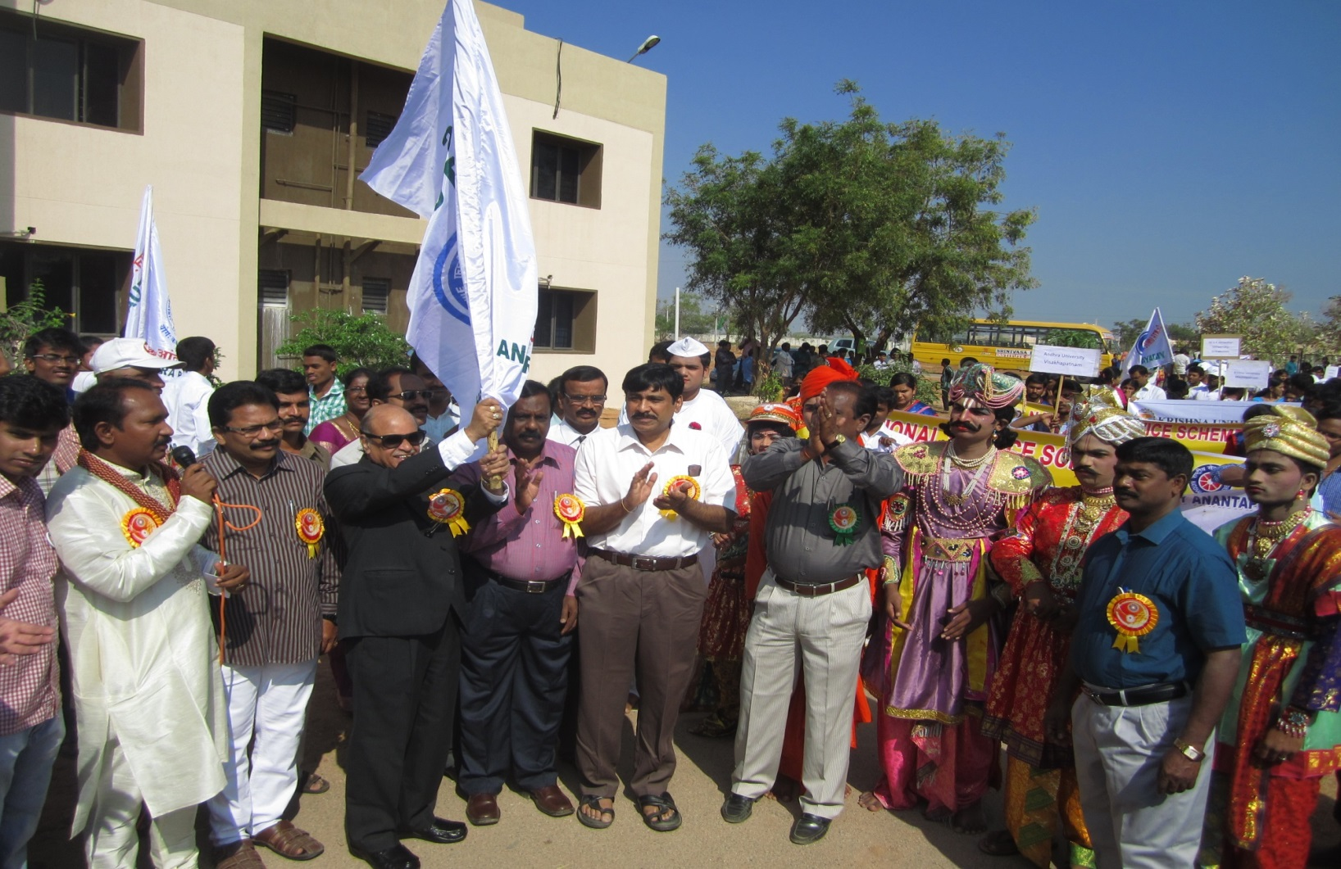
Sri R.Gokula Krishnan Youth Officer & Head Regional Center, Hyderabad, Ministry of Youth Affairs and Sports, Govt. of India, Sri P.Ramachandra Rao NSS State Liasion Officer, Govt.of A.P., Dr. M.S.N.Reddy NSS State Liasion Officer, Govt. of Telangana, Dr. N.A.D.Pal Training Coordinator, UTOC, Visakapatnam were attended as Guest of Honours and Prof.M.L.S.Deva Kumar NSS University Programme Coordinator, JNTUA as convenor of the Youth Festival.

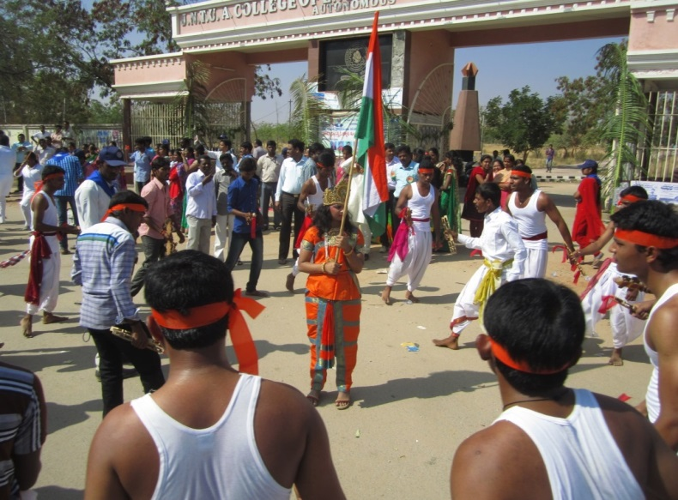
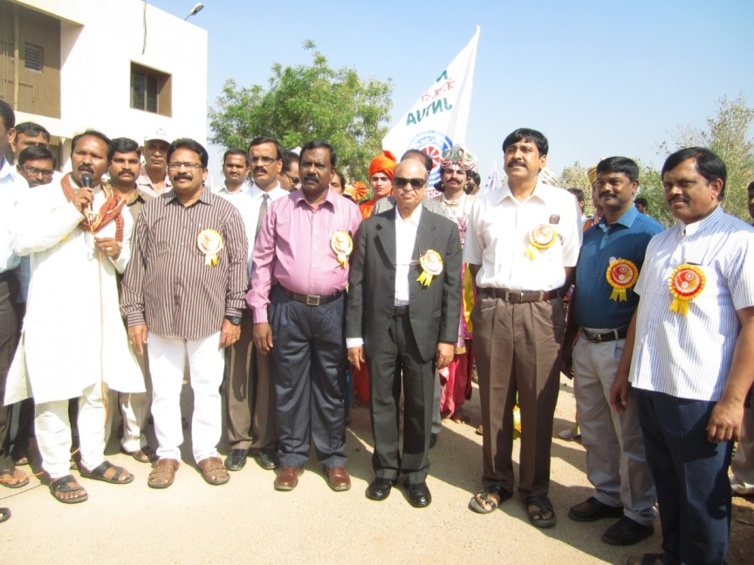
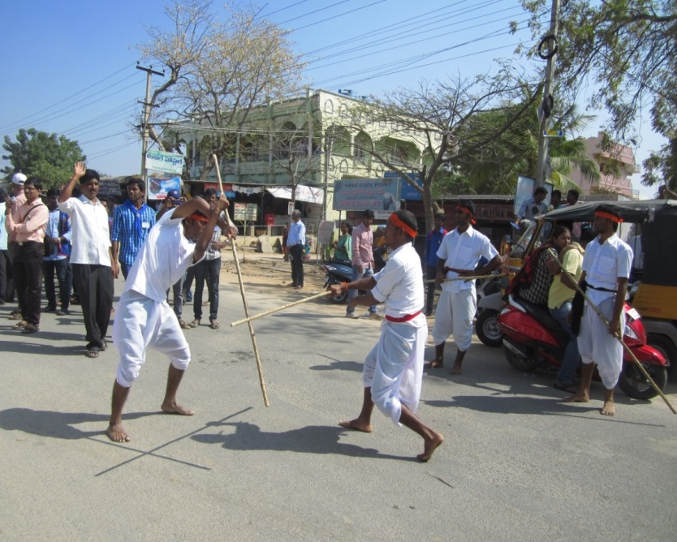
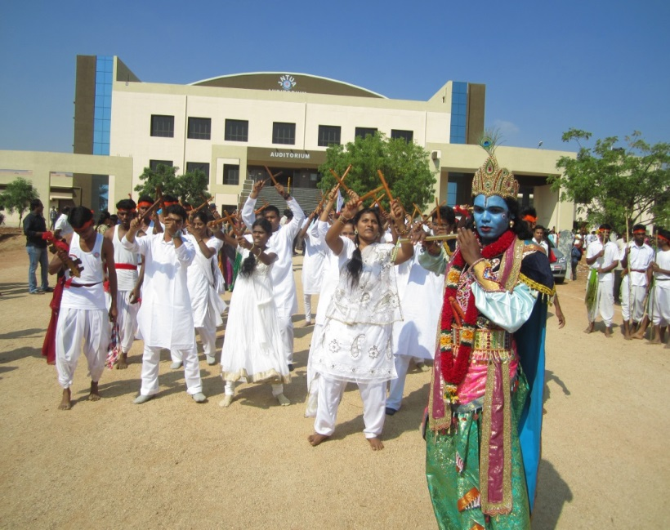
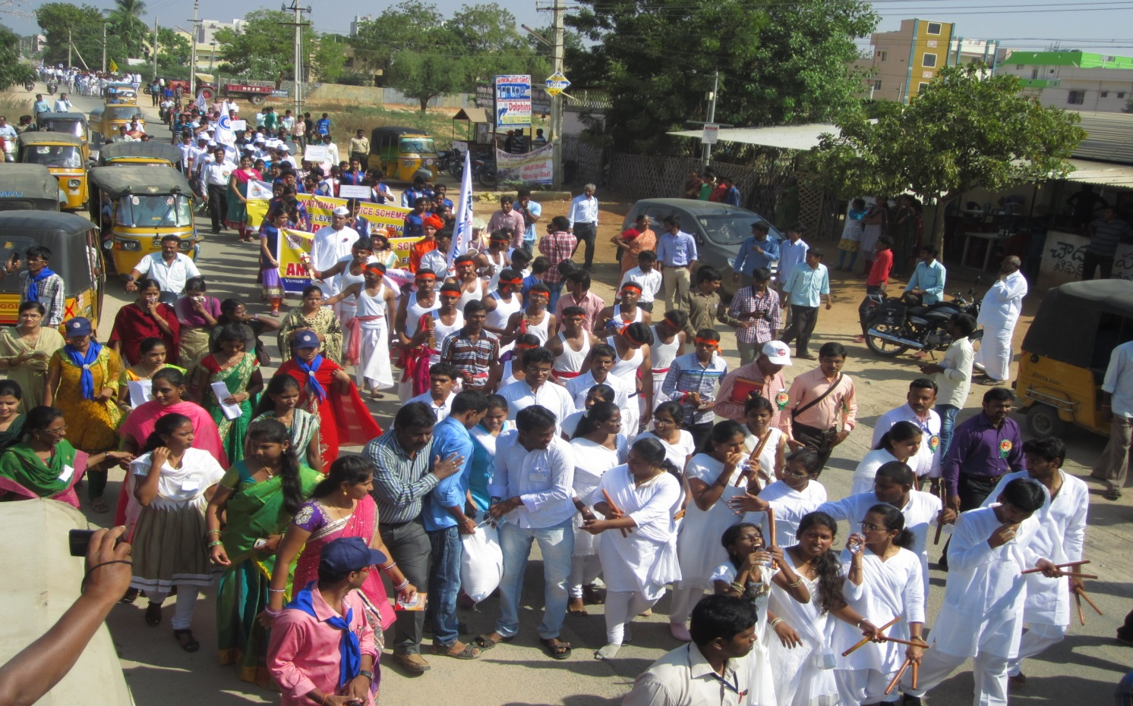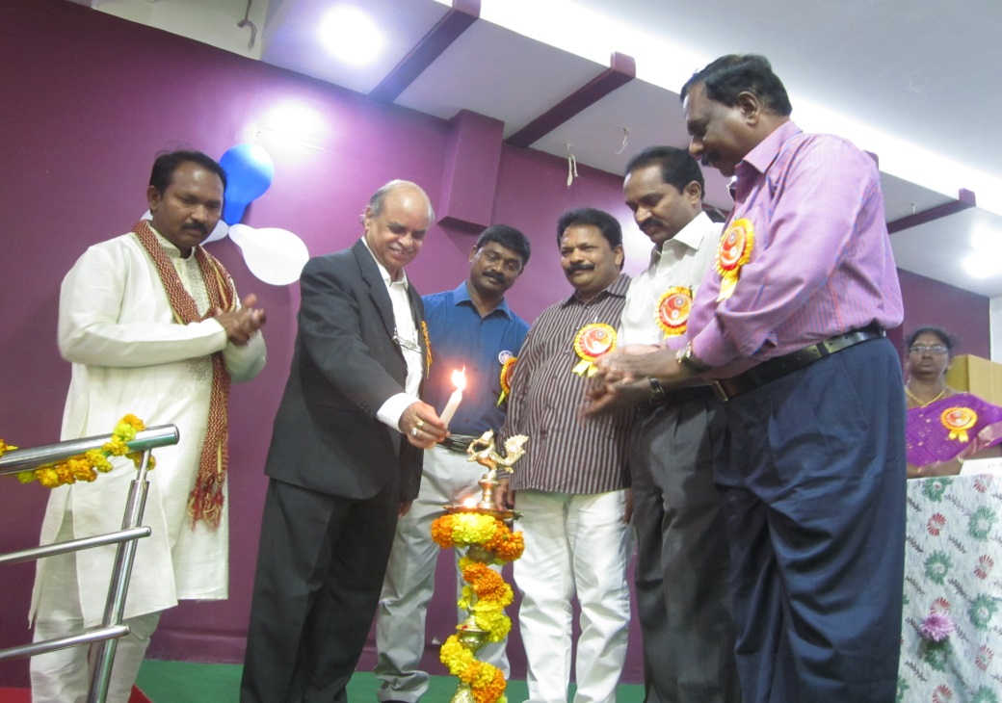
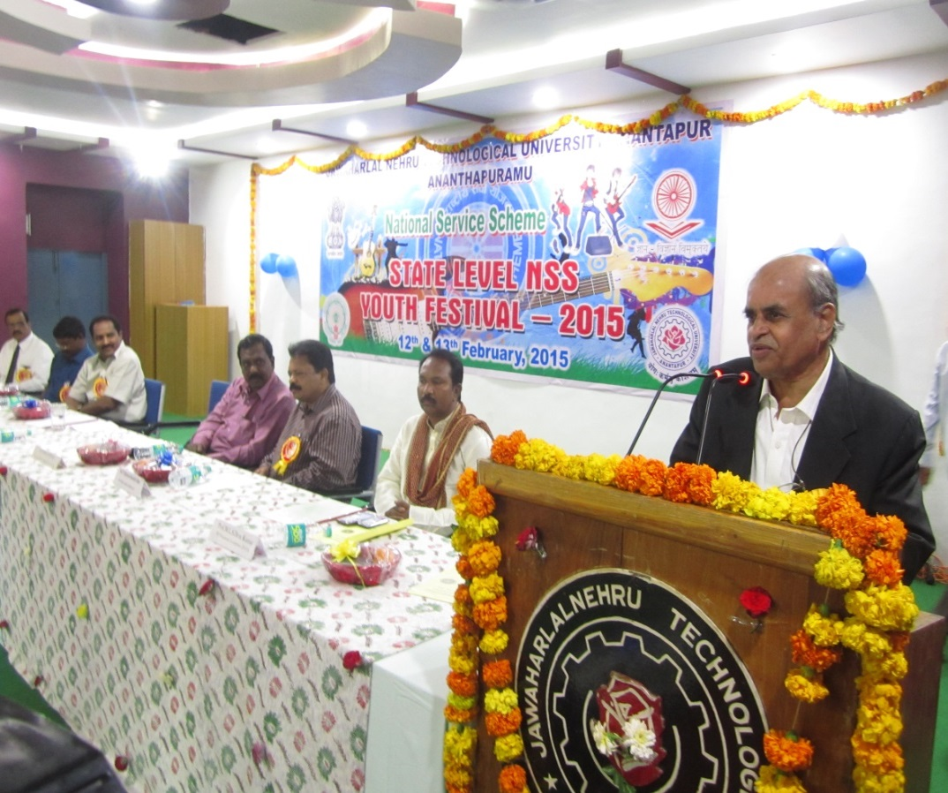
The inaugural function is started with ‘Lighting the Lamp’ by all the dignitaries, an invocation song ‘We shall Overcome’ by NSS Choir of JNTUA. President of the function Prof. S.Krishnaiah welcomed all the participants, Convener of the Festival Prof. M.L.S.Deva Kumar read-out Festival Message “Yuvatha Meluko” (Youth-Wake up). Dr.N.A.D.Pal described importance of NSS. Sri.P.Ramachandra Rao described about various opportunities to the NSS volunteers, Dr.M.S.N.Reddy reminded the duties of Youth towards nation, Sri. R.Gokulakrishnan motivated students to take part in all the Good Activities NSS leading, especially Youth Festivals, SwachhaBharath, Janmabhoomi programmes etc., Chief Guest Prof. K.Lal Kishore congratulated all the participants for taking part in the State Level Youth Festival, he has given a call to all the youth to join hands toward “Better Society”, he expressed his happiness about the traditional talents volunteers of various volunteers exhibited during the Inaugural Rally. The Youth Festival was declared open by Honourable Vice-Chancellor, Prof. K.Lal Kishore. NSS Choir presented a number – Uthe Samaj Ke Liye – NSS Theme Song and ‘HindDesh Ke Nivasi’ – a patriatic song.

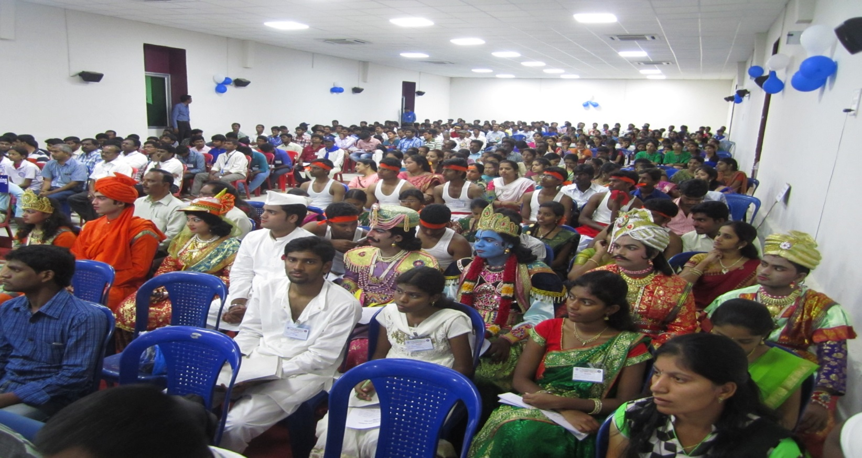

EVENTS

The competitions for the events Elocution, Essay writing, Debate, Poster painting, Quiz, Solo Singing, Solo Instrumental were conducted at the locations allotted in the brochure. The winners of the above mentioned eventswere declared by the respective
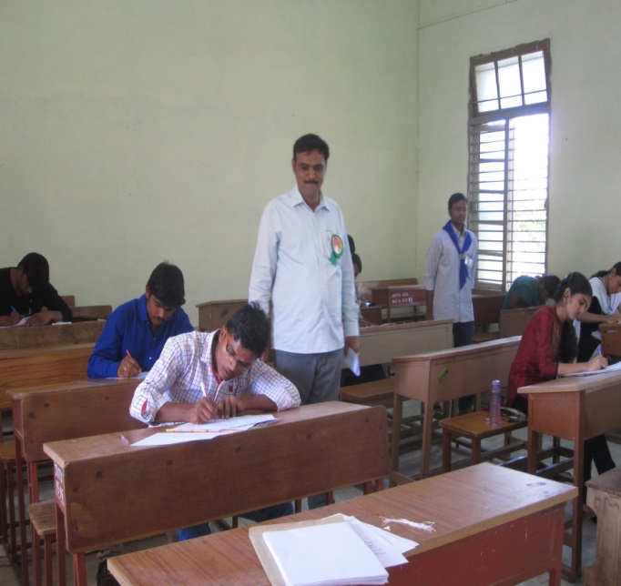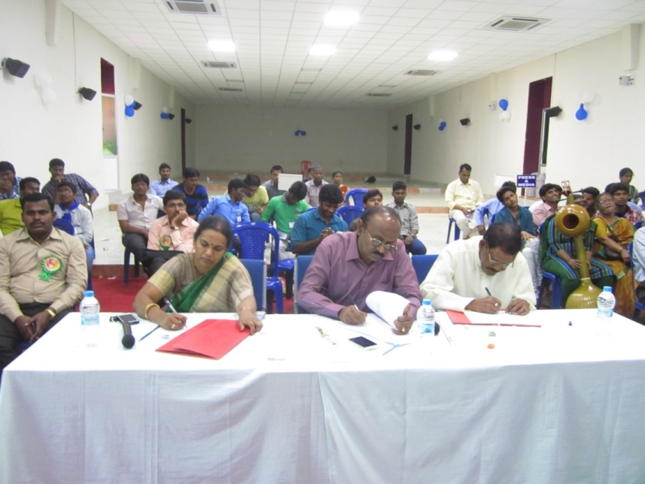
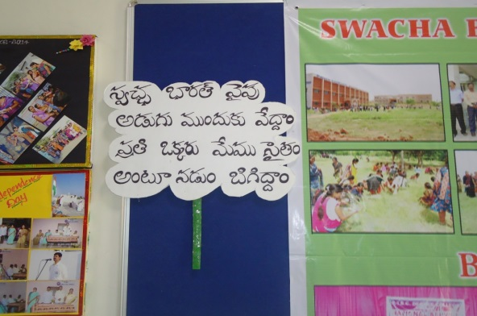
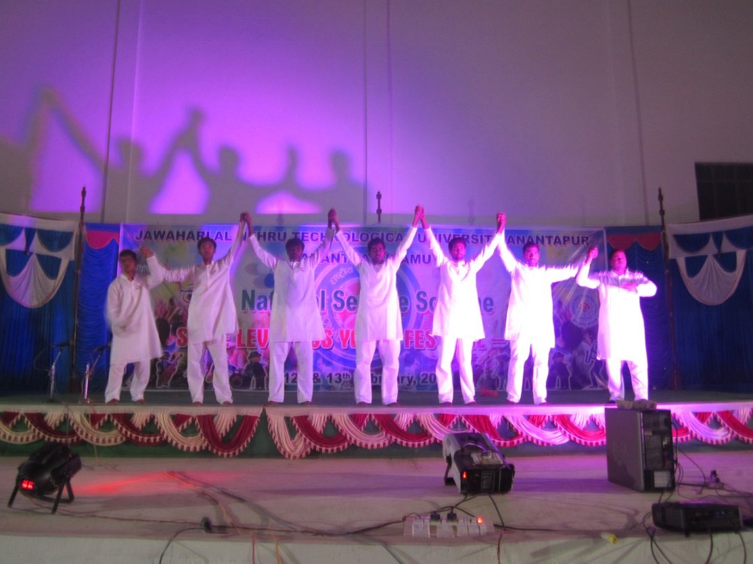
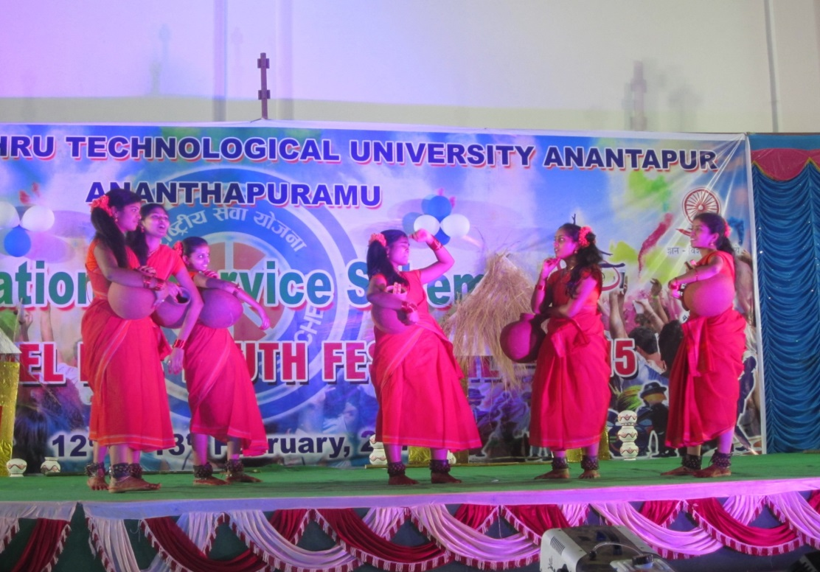
Judges. Evening cultural competitions viz., Classical Dance, Group Dance were conducted at the University Auditorium, where more than 2000 audience viewed the performances. The cultural competitions were started by the host University students welcome song (patriotic song). The students from the Universities performed several classical and group (folk) dances. The Auditorium Cherished with beautiful performances given by the participants and echoed with NSS clap.
After the cultural competitions, camp fire was conducted at the University Auditorium where the students participated irrespective of their Universities with great enthusiasm and shown their unity.

On 13th morning Rangoli, Photo Exhibition. Photo Exhibition is an event where the Universities were given a stall to exhibit their NSS activities by means of the photographs duly taken.

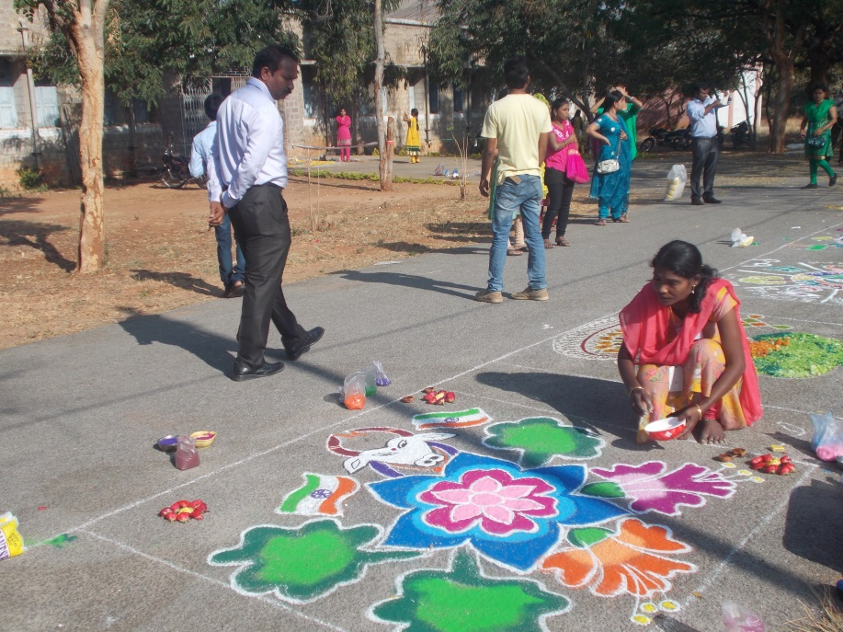
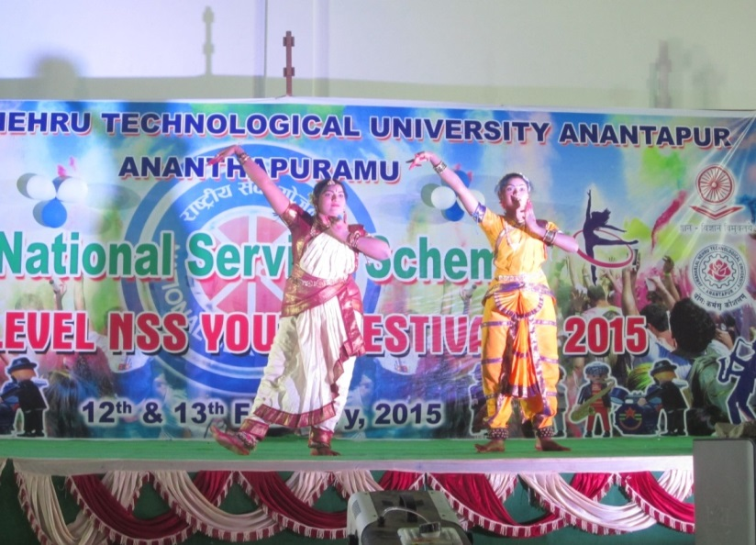
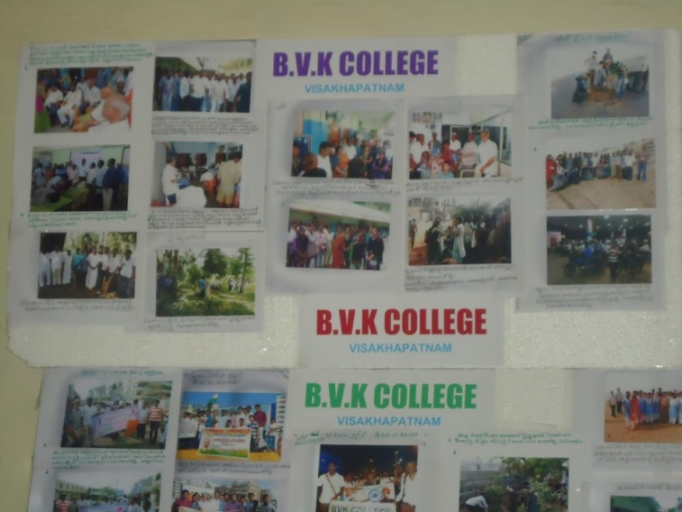
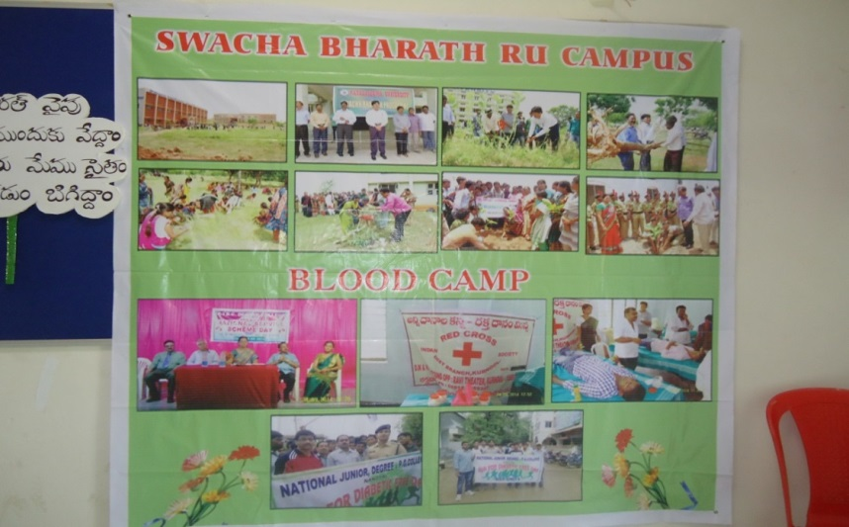
SUVICHAAR
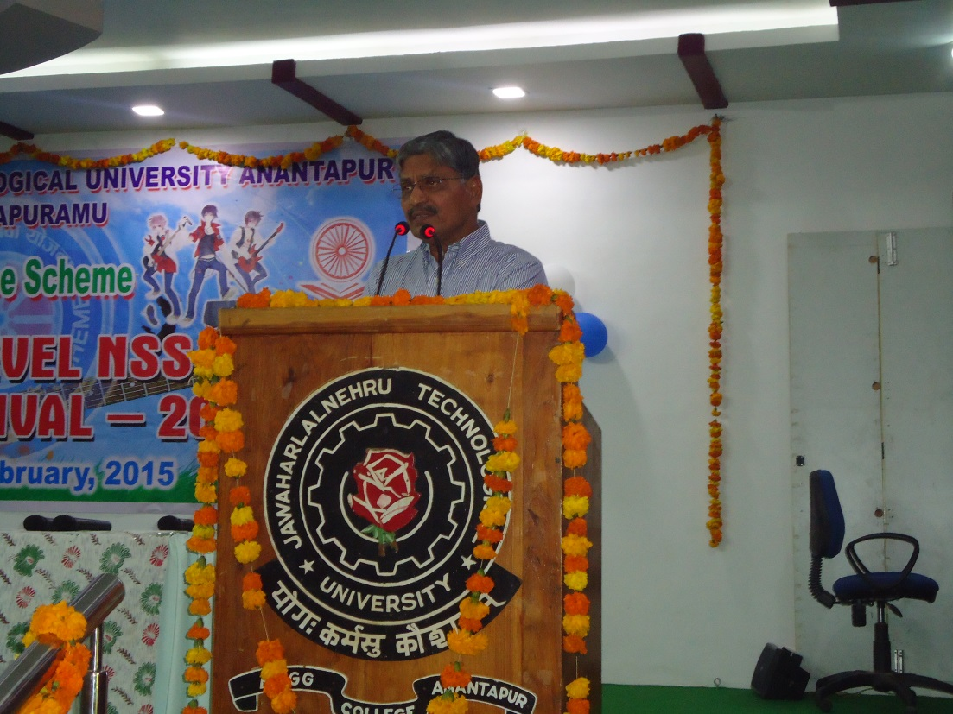
Next, intellectual sessions - SUVICHAAR was conducted in auditorium by eminent personalities Dr. Y.V. Malla Reddy, Sri T.Amarnath Reddy and Sri V.V.Ramakrishna Sastry who motivated the participants towards social service, national building, responsibilities of volunteers towards society.
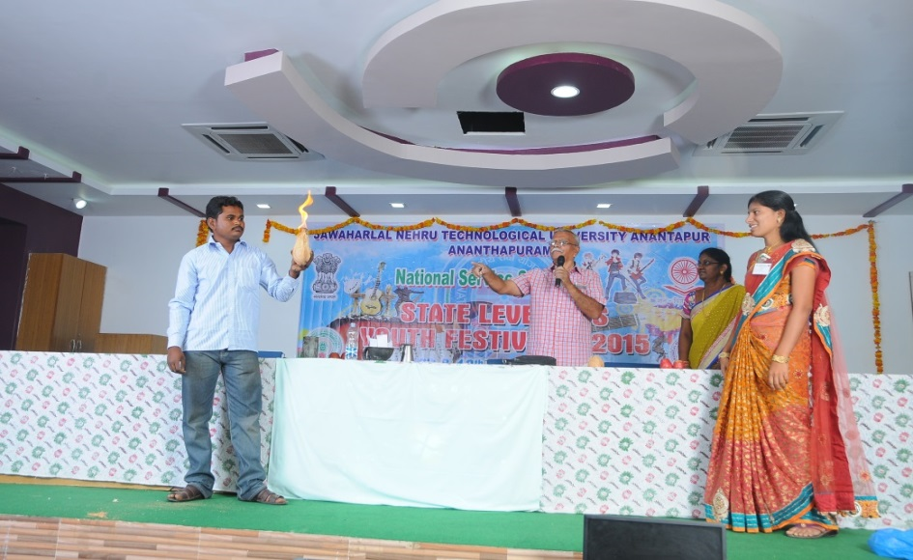
Dr. Y.V.Malla Reddy is the present Director of Action Fraterna Ecology Centre. He is a Fulbright Fellow and worked for about 40 years in Rural Development Trust. He was the member of A.P Water Conservation Mission(2000-04). He was honoured with title ANANTHA ANIMUTHYAMU by Sahithi Gagan Mahal Trust, Penukonda. He enlightened the audience as India is experiencing a good progress in industrial sector there by leading to economic growth, youth is having lot of responsibility in taking part in the Nation Building in right perspective. He then gave advice to students that youth is the only solution for contemporary problems like corruption; poverty etc., and added that youth is an energy house of our country.
Sri T.Amarnath Reddy Founder of Manavatha Blood Bank. He donated 47 times blood in his 65 years life. He received Prathibha Rajiv Puraskar Award in 2004. He explained about the necessity of blood donation and motivated students a lot in that regard and demonstrated about several misconceptions, dogmas by using which ‘Fake Godmen’ cheating the public. He explained the science behind the ‘miracles’, advised the youth to create awareness on human beliefs and superstitions.
Sri V.Venkata Ramakrishna Sastry a Senior Manager (Rtd) Syndicate Bank and Corporate Trainer explained the difference between ‘imitation and following’ and discussed the open fact that present youth is involved in imitating but not following. He then shared his observation in growth in Agricultural sector – Challenges and Solutions.

VALEDICTORY

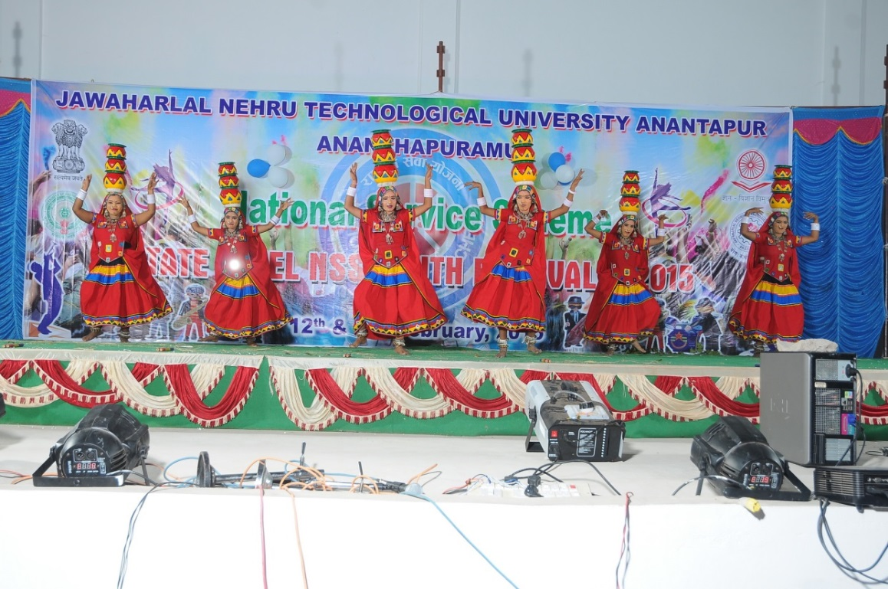
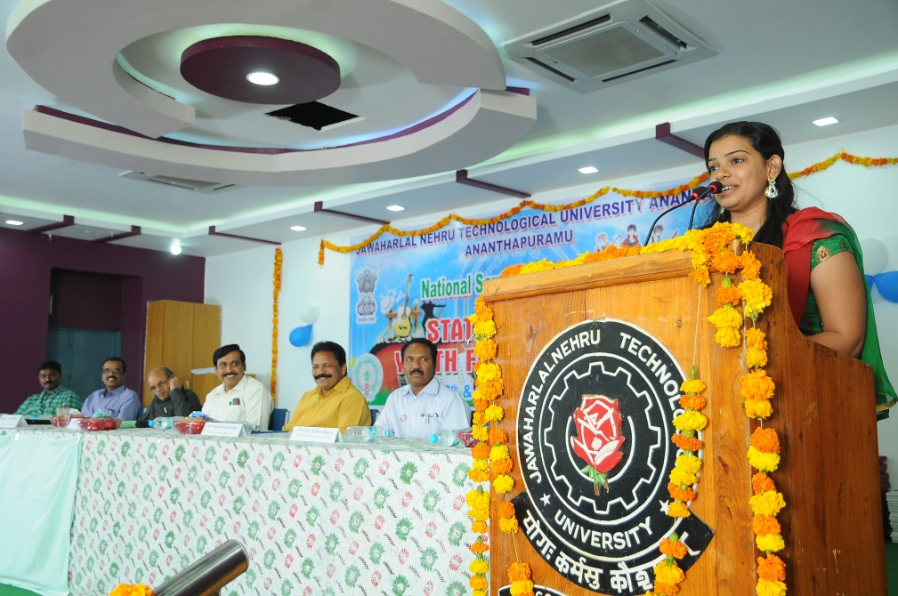
The evaluation for the competitions was made utmost unbiased and confidential. Respected Rector of JNTU Anantapur Prof.H.Sudharshan Rao presided over the Valedictory function. Prof. K.Lal Kishore Hon’ble Vice Chancellor, JNTUA graced the function as Chief Guest. In the presidential address Prof. H.Sudarsana Rao reminded the responsibilities of the NSS volunteers towards Adult Literacy, Educative and Awareness programmes on various social issues. Several participants shared their experience at the Youth Festival and presented their Feedback. Showing their talents, imitating Chief Minister of A.P. N.Chandra Babu Naidu, Opposition Leader Y.S.Jagan Mohan Reddy while giving feedback was hauled special attention. Sri.P.Ramachandra Rao NSS SLO (AP) congratulated the team of host University for successful conduction of the event. Dr.M.S.N.Reddy NSS SLO (TS) appreciated the effectiveness of NSS volunteers at JNTUA. Dr.N.A.D.Pal Training Coordinator, UTOC praised the administrative support of Hon’ble Vice Chancellor, Rector and Registrar of the University and applauded the ‘TEAM’ of JNTUA NSS. Prof. M.L.S.Deva Kumar Convener of the Event, NSS Programme Coordinaotor, JNTUA presented a report, where he expressed his delight for participation from all the 13 Universities of Andhra Pradesh and excellent support from University Administration, College Administration, Teaching Staff and Non Teaching Staff at different activities. He appreciated efforts of student volunteers for UNIQUE activities like maintaining and using a website for Information and Communication, Providing Handouts with complete details of the programmes with route map, ‘Freedom of Expression’ by running commentary by SMS – Display during cultural activities etc., Prof.K.Lal Kishore Hon’ble Vice Chancellor congratulated the TEAM – NSS for excellent planning and execution of the Youth Festival Activities. He assured of Universities support for the forthcoming NSS activities even at National Level. All the Judges were honoured by the dignitaries by presenting ‘Mementoes’. Then winners of various events at First, Second, Third places and few Consolation places were presented with a Memento, a certificate by the dignitaries. The Andhra University, Visakhapatnam was declared as overall champion for the Youth festival. The second overall championship was awarded to Rayalaseema University, Kurnool. A ‘Rolling Trouphy’ was presented to Overall Champion Team.
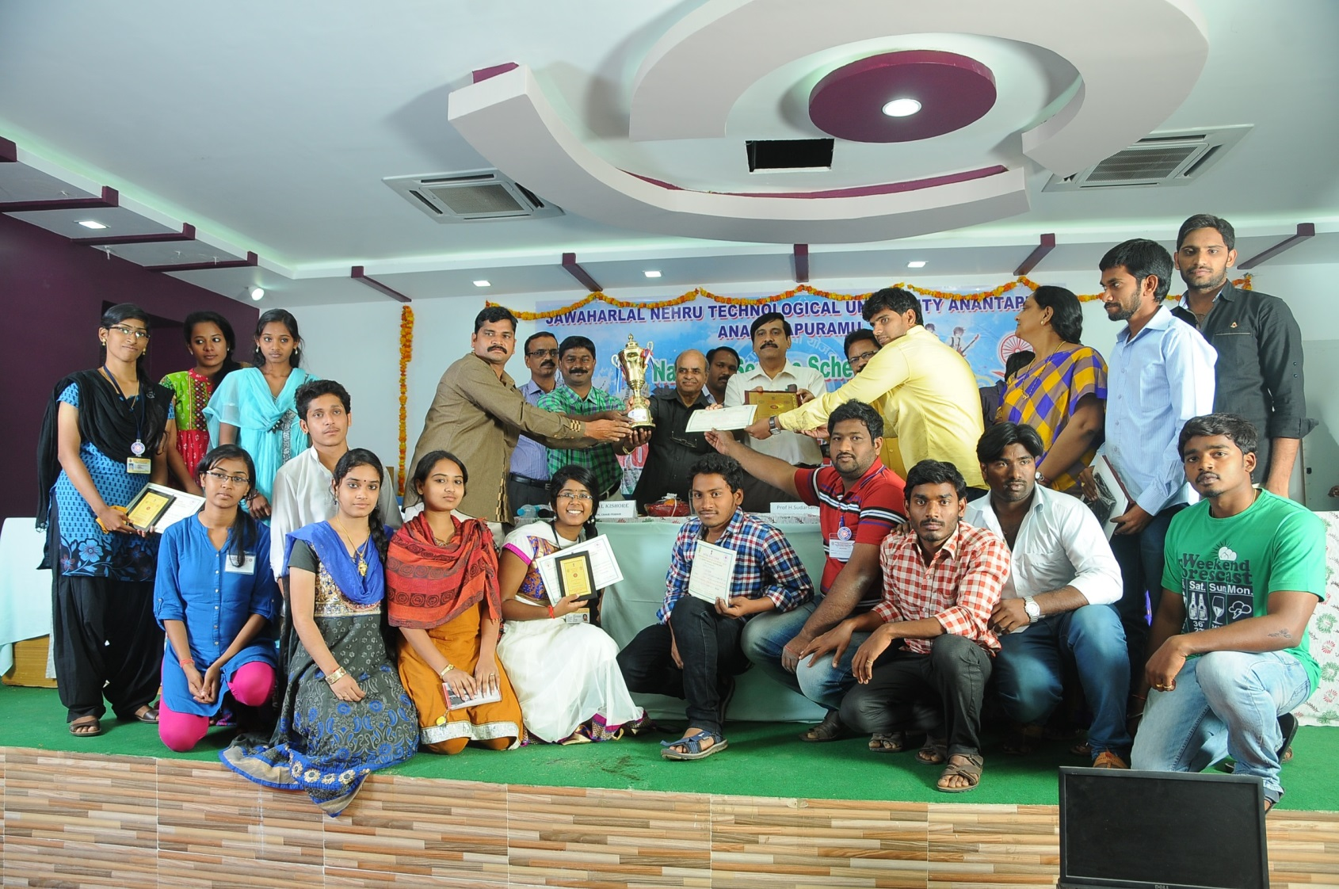
SUPPORT:Apart from participation fee @ Rs.200/- from each participant, University has provided financial sanction from U.G.C.XII Plan grants allocated for N.S.S. Cultural Activities. Annamacharya Institute of Technology & Science, Tirupathi has sponsored one Lunch. Madanapalle Institute of Technology & Science, Madanapalle has sponsored Files to the participants. Local transportation is provided by Anantha Lakshmi Institute of Technology & Sciences Anantapur, Intell Engineering College Anantapur and Srinivasa Ramanujan Institute of Technology Rotarypuram.
State Level NSS Youth Festival on 12th& 13th February, 2015 at
J.N.T. University Anantapur, Ananthapuramu
Winners List

Event | Pize | Name | University
Elocution | 1 | N.PREM KUMAR | ADIKAVI NANNAYA UNIVERSITY
 | 2 | SHAIK. AOPSANA | RAYALASEEMA UNIVERSITY
 | 3 | M.SHRUTHI GOPINATH | ANDHRA UNIVERSITY
Debate | 1 | G.MOHSINA & S.SANIYA | SRI VENKATESHWARA UNIVERSITY
 | 2 | P.V.SAI SWETHA & U.S.KRISHNA SAHITHI | ANDHRA UNIVERSITY
 | 3 | G.S.M.S.SAINATH & G.AKHILA | N.T.R UNIVERSITY OF HEALTH SCIENCES
Essay Writing | 1 | K.GAYATHRI | SRI VENKATESHWARA UNIVERSITY
 | 2 | H.KAILASANATH | YOGI VEMANA UNIVERSITY
 | 3 | V.HARI PRIYA | SRI PADMAVATHI MAHILA UNIVERSITY
 |  | K.VINAY KUMAR | VIKRAMA SIMHAPURI UNIVERSITY
Quiz | 1 | C.ANVESH ,M.VENKATESH, P.NAVYA | YOGI VEMANA UNIVERSITY
 | 2 | M.D.MEHBOOB KHAN, S.GOVINDA RAO, VEERA SEKHAR | RAYALSEEMA UNIVERSITY
 | 3 | A.NAGENDRA, Y.RANGA REDDY, G.VIJAYA KUMAR | SRI KRISHNADEVARAYA UNIVERSITY
Patriotic Poem | 1 | M.N.S.RAMA KIRAN | ANDHRA UNIVERSITY
 | 2 | K.DAMODHAR | VIKRAMA SIMHAPURI UNIVERSITY
 | 3 | V.S.V.V.MANIKANTA | ADI KAVI NANNAYA UNIVERSITY
 | Consolation | G.PADMAVATHI | YOGI VEMANA UNIVERSITY
Poster painting | 1 | C.PRASANTH | RAYALASEEMA UNIVERSITY
 | 2 | G.SOMA SEKHAR | SRI KRISHNADEVARAYA UNIVERSITY
 | 3 | S.YELLAYYA | ANDAHRA UNIVERSITY
Rangoli | 1 | B.SOWMYA SREE | RAYALASEEMA UNIVERSITY
 | 2 | B.SARADA | SRI VENKATESHWARA UNIVERSITY
 | 3 | M.LAKSHMI BHAVANI | ADIKAVI NANNAYA UNIVERSITY
Solo  Instruments | 1 | M.SAI MUTHYALU | ADIKAVI NANNAYA UNIVERSITY
 | 2 | JAYAVRAT DUBEY | ANDHRA UNIVERSITY
 | 3 | G.SAI SIREESHA | Dr.N.T.R UNIVERSITY OF HEALTH SCIENCES
Solo song | 1 | B.SANTHI PRIYA | SRI PADMAVATHI MAHILA UNIVERSITY
 | 2 | D.V.KAMESHWARI | ANDHRA UNIVERSITY
 | 3 | G.MANI | ADIKAVI NANNAYA UNIVERSITY
Classical Dance | 1 | B.AKHILA REDDY | KRISHNA UNIVERSITY
 | 2 | K.ANJALI | RAYALASEEMA UNIVERSITY
 | 3 | M.MAHALAKSHMI | SRI KRISHNADEVARAYA UNIVERSITY
 | CONSOLATION | J.PRANATI | Dr.N.T.R UNIVERSITY OF HEALTH SCIENCES
Group Dance | 1 | P.S.SHAHEEN, T.UMADEVI, M.THRIPULA, S.JAYA SREE, D.RESHMA, B.HEMA LATHA | SRI KRISHNADEVARAYA UNIVERSITY
 | 2 | Y.JHANSI RANI, G.JHANSI RANI , CH.NEELIMA, B.DEPIKA,Y.MANEESHA,  D.V.R.BHARGAVI | ADIKAVI NANNAYA UNIVERSITY
 | 3 | R.BHAVANI SREE, G.YARSHIKA, K.ROHINI, K. RAJESWARI, P.BHANUPRIYA, S.V.HARIKA | JAWAHARLAL NEHRU TECHNOLOGICAL  UNIVERSITY ANANTAPUR
 | CONSOLATION | YOGI VEMANA UNIVERSITY TEAM | YOGI VEMANA UNIVERSITY
Photo exhibhition | 1 | ANDHRA UNIVERSITY TEAM | ANDHRA UNIVERSITY
 | 2 | RAYALASEEM UNIVERSITY TEAM | RAYALASEEMA UNIVERSITY
 | 3 | SRI KRISHNADEVARAYA UNIVERSITY TEAM | SRI KRISHNADEVARAYA UNIVERSITY
OVERALL  CHAMPIONSHIP | 1 | ANDHRA UNIVERSITY
 | 2 | RAYALSEEMA UNIVERSITY

The FIRST STATE LEVEL NSS YOUTH FESTIVAL OF ANDHRA PRADESH STATE (After Re-organisation) is made possible to conduct at J.N.T.University Anantapur, Ananthapuramu successfully ONLY with great support from Youth Officer & Head, State Liaison Officer, JNTUA University Administration, entire staff of JNTUA, Programme Co-ordinators of all Universities, Contingent Leaders of various Universities, Participants from various Universities, especially relentless efforts of Dr.T.Narayana Reddy, Officer-in-charge JNTUA Hostels, Dr. E. Aruna kanthi, NSS PO JNTUA, Dr.B.Chandra Mohana Reddy, Officer-in-charge MBA & NSS PO, Sri M.Rama Sekhar Reddy, Public Relations Officer JNTUA, Sri Rajesh Sam, Faculty Incharge of NSS, MBA Department and all the committed NSS volunteers of JNTUA.

--- Prepared by
Information & Communication Team, NSS – JNTUA.

