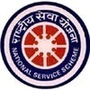
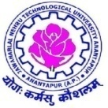
JAWAHARLAL NEHRU TECHNOLOGICAL UNIVERSITY ANANTAPUR.
ANANTHAPURAMU - 515 002.
National Service Scheme (N.S.S.) Cell.
A One Day Workshop on “YUVA SADHIKARIKA NIRUDHYOGA BHRUTHI” (Financial Assistance to Educated Unemployed Youth)
on 20th December, 2017 – Report

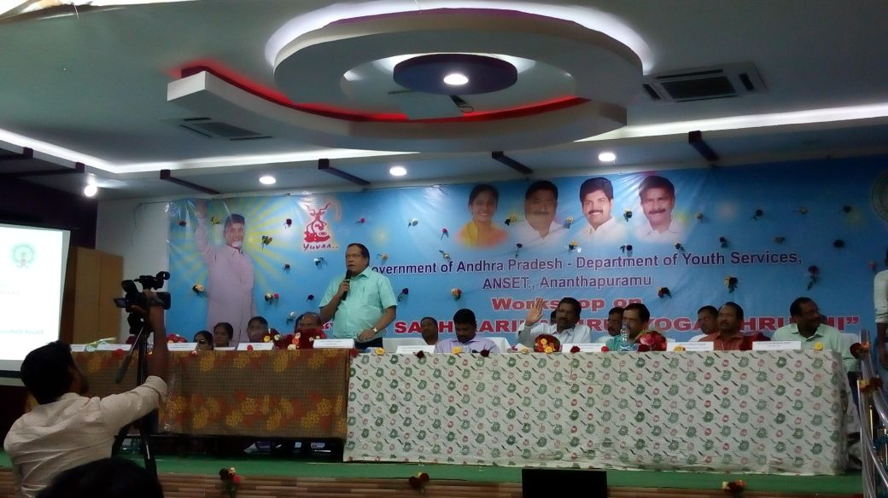
A one day workshop on “YUVA SADHIKARIKA NIRUDYOGA BHRUTI (Financial Assistance to Educated Unemployed Youth)” is held on 20th December 2017, organized by National Service Scheme (NSS) in association with Dept of Youth Services, ANSET, Govt. Of A.P., The Collector & District Magistrate Sri G.Veerapandiyan IAS and JNTUA Vice Chancellor Prof. S.Srinivas Kumar were Chief Guests of the workshop. Prof. K.Prahlada Rao Principal of JNTUA College of Engineering, Anantapur presided over the inaugural function. Sri. Venkatesam, CEO, ANSET, Anantapur and Prof. M.L.S.Deva Kumar NSS Programme Coordinator, JNTUA moderated the workshop.
The main motto of this workshop is to present the draft guidelines for the proposed ‘Financial Assistance to Educated Unemployed Youth’ in the state of Andhra Pradesh by Govt. Of A.P., to discuss on various issues pertaining to it, to conduct brainstorming sessions and to get the feedback and advices from the Youth and Students.
The workshop started with invocation and invitation of Smt. D.Lalitha Kumari, NSS Programme Officer, Unit – III, JNTUA College of Engineering, Anantapur. Prof. K. Prahlada Rao welcomed the all the District Officials, Heads of Educational Institutions, Various Organizations, NGOs and all the participants. In his welcome address he requested all the participants to be active throughout the workshop to have meaningful discussions and to arrive at good outcomes. Sri. G.Venkatesm CEO, ANSET, Dept. Of Youth Services, Govt. Of Andhra Pradesh explained the objective of the workshop as to involve youth and students in shaping the proposed scheme an effective one. He explained the activities of Dept of Youth Services and requested all the youth to make use of them. Mr. Subramanyam presented the draft guidelines of the scheme and opened the discussions of various District Officials. Smt. Kalyani District Employment Officer explained about enrolment for employment, training programmes being organised by District Employment Office. She advised students to understand the requirements of the employer before completing the studies and to make arrangements to appear for various selection procedures.
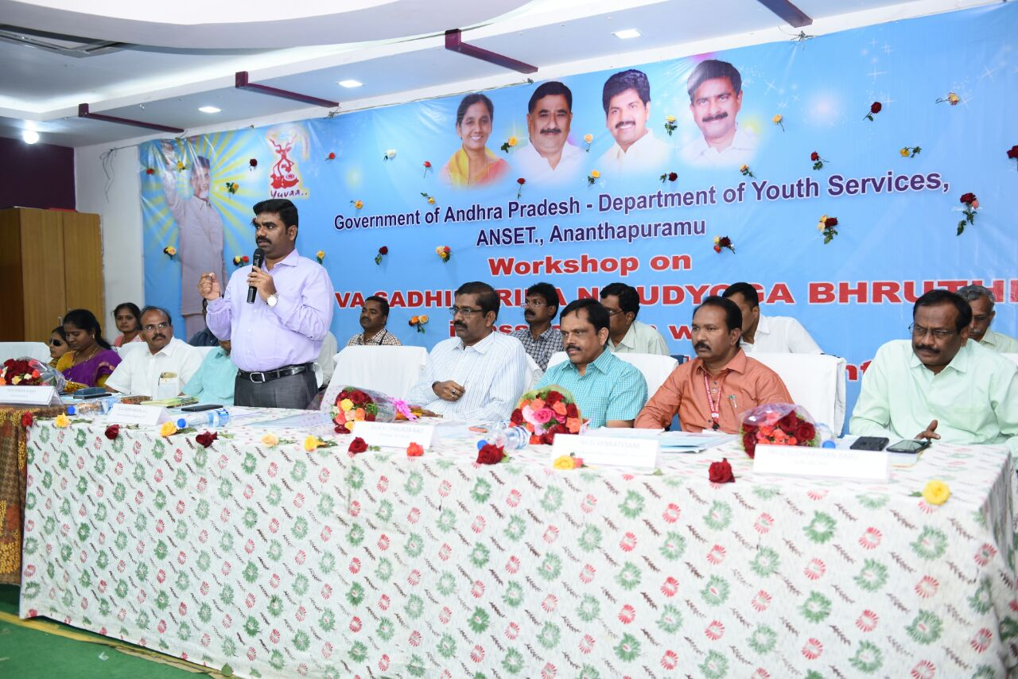
Sri. G.Sudarshan Babu General Manager, District Industries Center Anantapur explained about various opportunities available for the Unemployed youth to become employees as well as employers. He presented the prospective opportunities in Anantapur district due to establishment of various industries including Kia Motors a Korean company. Prof. M.L.S.Deva Kumar NSS Programme Coordinator JNTUA & Vice Principal JNTUACEA explained the need of spreading the information to the youth and students regarding various schemes of Government and various opportunities for the unemployed youth. He directed all the NSS Volunteers to include this activity in the NSS Special Camps in the villages. He stressed up on acquiring specialised knowledge on related even in narrow area to get placed by industry. He quoted example of having through knowledge on MS Excel or FOREX fetched the best opportunities to the students. Even command on a foreign language can fetch good job opportunities.
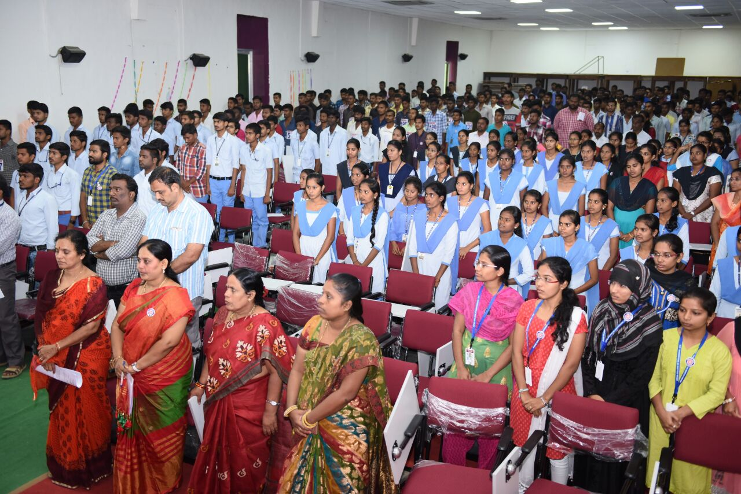
Hon’ble Vice Chancellor Prof. S.Srinivas Kumar, JNTUA described the opportunities available for the Engineering Graduates in the present situation. He advised all the students to concentrate on skill based training programmes to enhance the opportunities. He projected the commitment on this skill development programmes by the Govt. Of India, Govt. Of AP and also JNTUA. He invited all the Engineering Youth to make use of SIEMENS Centre of Excellence at JNTUACEA for improving the technical skills in various domains.
Sri. G.Veera Pandian IAS Collector and District Magistrate, congratulated all the youth for having such great opportunity to learn contemporary technologies at the door step. He encouraged students and youth to involve in various development works of the Governments and to do social service during their studies. He presented on progress of KIA Motors company and potential for getting jobs in many ancillary units connected to it.
Sri. N.Ramakrishna President, Indian Red Cross Anantapur presented about requirements of youth in social service for the development of the society. He promised to plan many service trainings for the youth also.
The programme continued with discussions and debates by the participants in the post lunch session. Sri Venkatesam and team consolidated the discussions. Smt. Bhavani of Dept of Youth Services presented the vote of thanks and closed the workshop. JNTUACEA NSS Programme Officers Smt. D.Lalitha Kumari, Dr. K.Jithendra Gowd and Sri. M.Ramasekhar Reddy co-ordinated the programme. Dr. Keshava Chandra Rao Principal, Govt. Polytechnic, Sri. Suresh Principal, KSN Jr College for Girls, Sri. Sriramulu Naik NSS PO, Govt. Degree College, Faculty and students from KSN Junior College, KSR Degree College, PVKK Engineering Collge, Govt. Polytechnic, JNTUA College of Engineering and Youth of Ananthapuramu participated in the programme.

