A REPORT
ON
INTERNATIONAL DAY OF YOGA
CONDUCTED
BY
NSS UNITS, J.N.T.University Anantapur (JNTUA)
Ananthapuramu-515002

The International Day of Yoga is observed at all NSS Units of J.N.T.Univerity Anantapur, Ananthapuramu on 21st June, 2017. At University Head Quarters NSS CELL has organized a Lecture on Yoga, followed by MASS YOGA PRACTICE. The program started at 6:30 a.m and continued up to 8:30 a.m. In this programme all the people who comes to JNTUA grounds for walking and motivated them to follow YOGA. The staff, students, NSS Volunteers, Walkers attended the program. Anantapur Prof. S. Krishnaiah, Registrar, JNTUA has greeted all the participants on this occasion. The program coordinator Prof. M.L.S.Deva Kumar, NSS Programme Coordinator invited all the participants to practice Yoga regularly. Registrar Prof. S. Krishnaiah,Principal Prof. K. Prahlada Rao congratulated all the participants. Lt. S. Sharada etc., NSS Po were lead the gathering , and conducting the programme.

All NSS Units at their respective places organized awareness programs, on yoga and conducted mass yoga practice sessions. The detailed are present below .

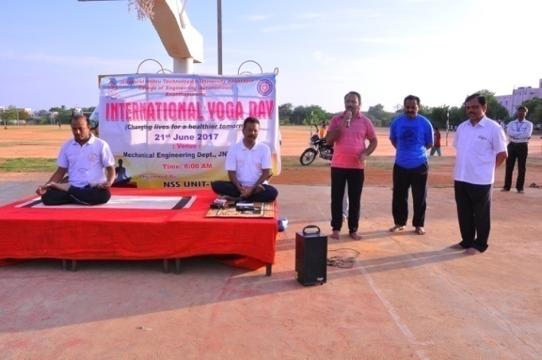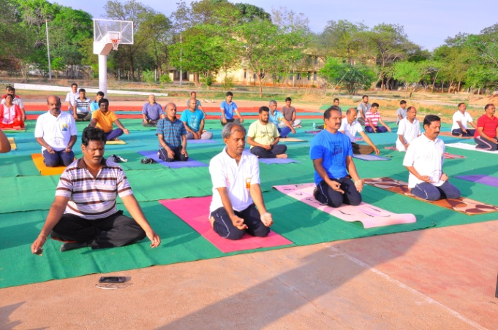
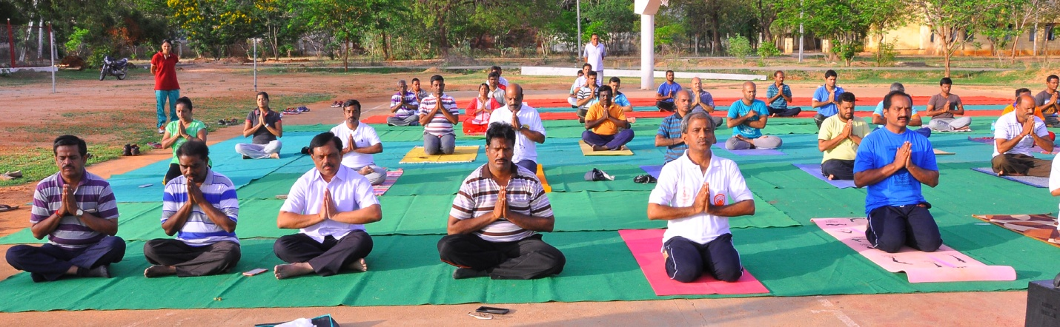
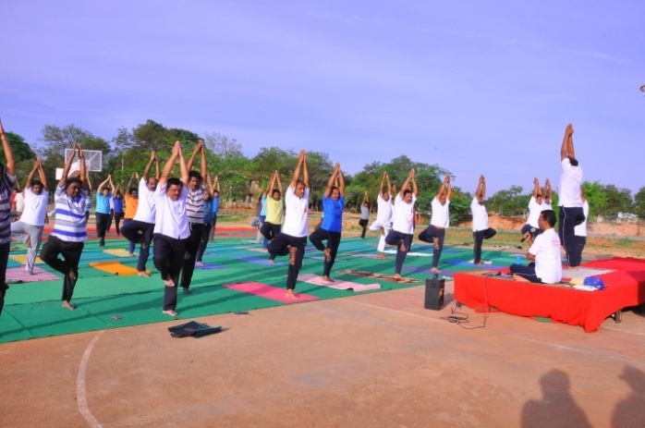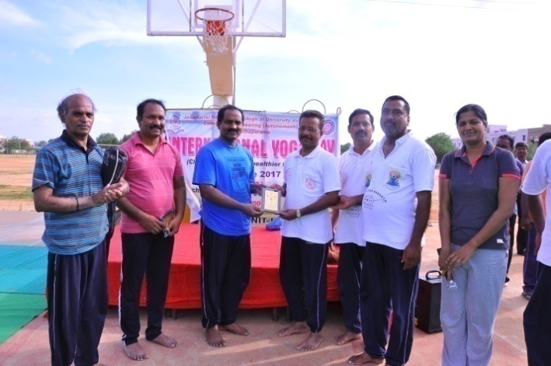
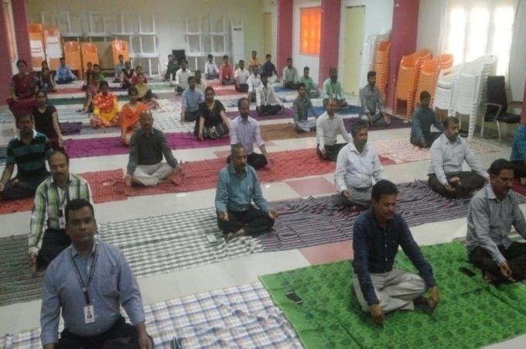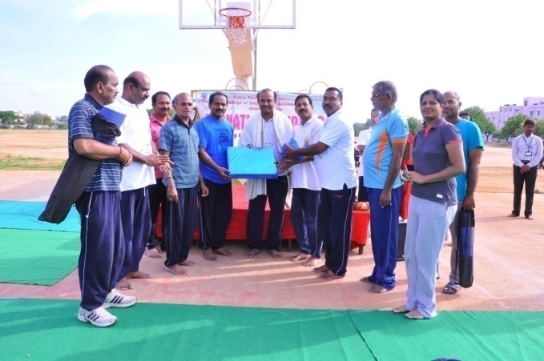
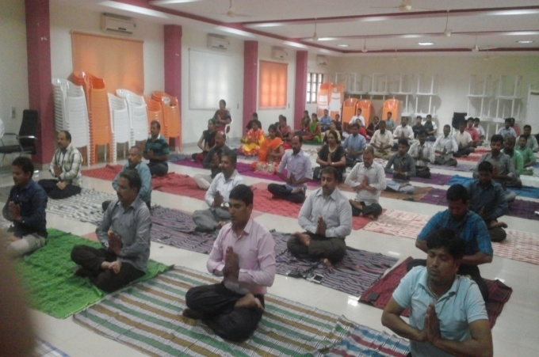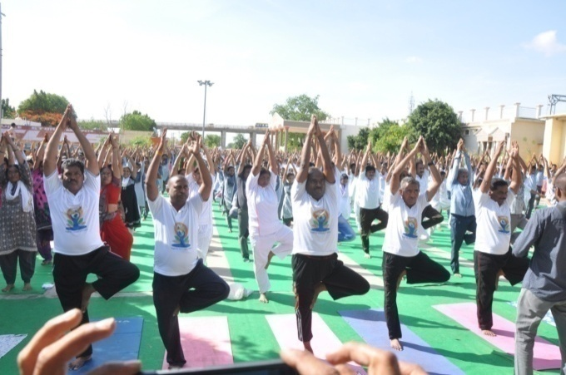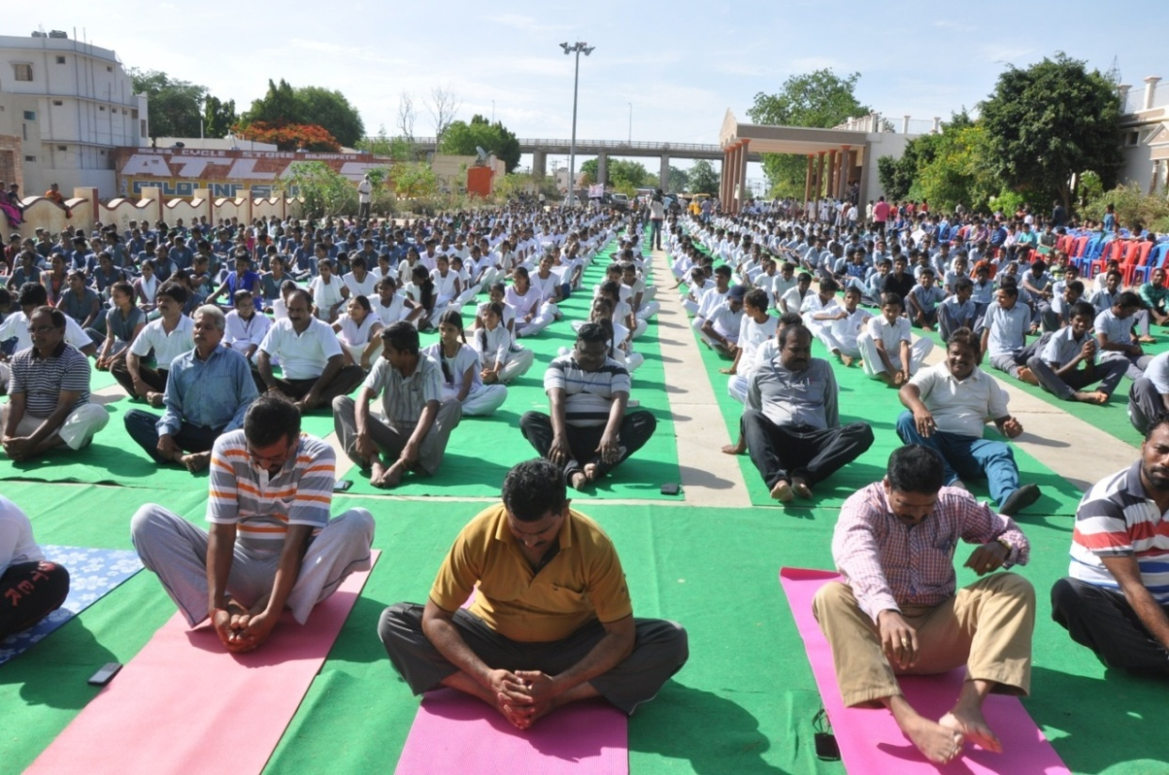
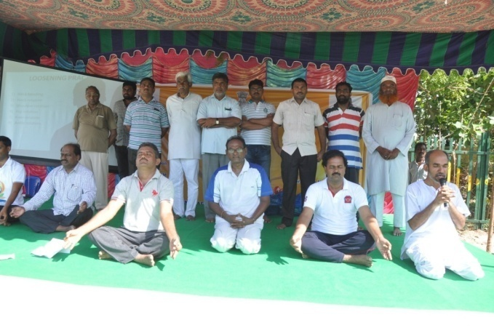
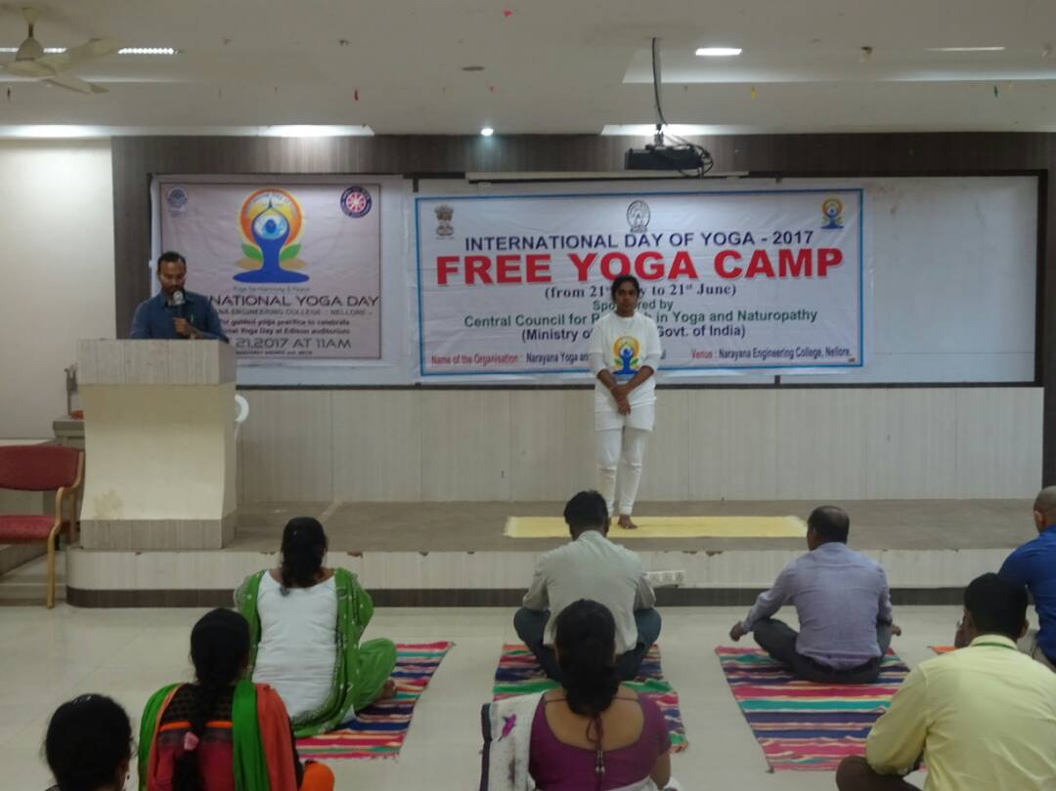

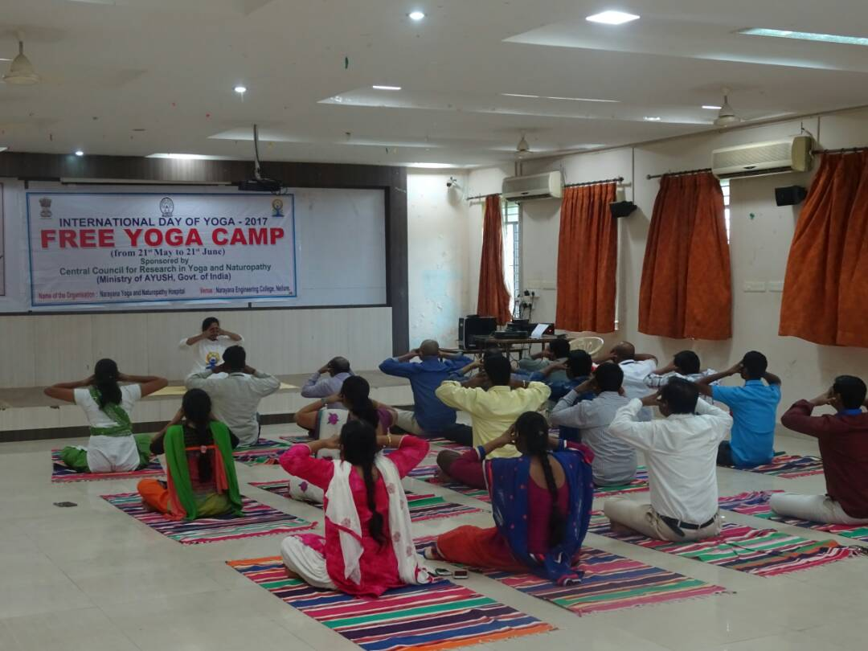
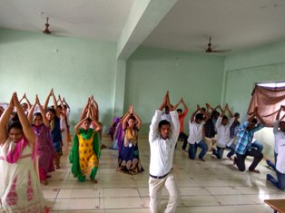

Prof. M.L.S.Deva Kumar
NSS Co-ordinator, JNTUA,
ANANTHAPURAMU

