NATIONAL SERVICE SCHEME
JAWAHARLAL NEHRU TECHNOLOGICAL UNIVERSITYANANTAPUR
ANANTAPUR – 515 002 (A.P) INDIA

BRIEF REPORT ON VANAM MANAM PROGRAM
As per the directions of Goverment of Andhra Pradesh, Jawaharlal Nehru Technological University Anantapur, Anathapuramu has organised ‘VANAM – MANAM’ a Massive Plantation Programme in the University Campus as well as in all the affiliated colleges spread over five districts of Andhra Pradesh.
Hon’ble Vice Chancellor Prof. M.M.M.Sarcar convened a meeting of VANAM – MANAM spearhead team in the University Conference Hall immedietly after the Video Conference with Chairman APSCHE Prof. L.Venugopal Reddy and Officers of APSCHE on 28th July, 2016. The University Administrative Officers Prof. V.Pandurangadu Rector, Prof. S.Krishanaiah Registrar directed all the functioneries for necessary arrangements to be made for VANAM – MANAM programme.
Prof. M.L.S.Deva Kumar NSS Programme Coordiantor was identified as Officer Incharge for VANAM-MANAM programme. NSS Programme Officers Smt. D.Lalitha Kumari, Lt.S.Sharada, Dr.B.Dilip Kumar, Dr. T.Narayana Reddy lead the NSS volunteers for plantation Programme, Lt. S.Sharada lead the NCC cadets under the leadership of Prof. K.Prahlada Rao Principal JNTUA College of Engineering, Anantapur. University Engineer Sri. Narayanana Reddy, DEE SivalingaRao made all arrangements for transporting the saplings, pitting activities.
All the Directors of the Unviersity, Teaching Staff and Non Teaching Staff participated in the VANAM – MANAM a massive plantation programme on 29th July, 2016 from 9:00 a.m. to 1:00 p.m. The activitiy planned meticulously taking support of District Forest Department and an NGO Rural Devolpment Trust. Saplings were lifted from the Nursery being maintained in the University Campus itself and from RDT nursery. The campus area near the PG boys hostels assigned to NSS Unit – III where all PG students are participated. Dept. Of Management took responsibility of plantation near Alumni Guest House, NSS Unit- I and Unit-II took responsibility of plantation near Nehru Statue and along the foot path. NCC Girls Unit took responsibility of plantation infront of Administrative Block of the University. In the University Campus it self around 1000 saplings were planted involving Teaching Staff, Non Teaching Staff and Students.
Similarly all the affiliated colleges took part in the same activity at their respective campuses. On one day 20120 samplings were planted in the jurisdiction of J.N.T.University Anantapur, Ananthapuramu.
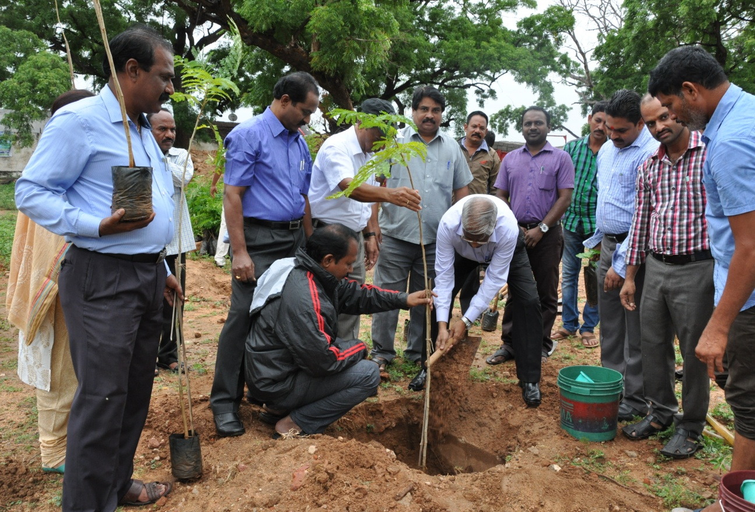
SAMPLE PHOTOGRAPHS OF THE ACTIVITY
