NATIONAL SERVICE SCHEME
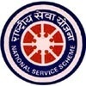
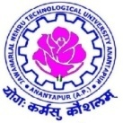
JAWAHARLAL NEHRU TECHNOLOGICAL UNIVERSITYANANTAPUR
ANANTAPUR – 515 002 (A.P) INDIA

JNTUA NSS RECEIVED STATE BEST NSS PROGRAMME COORDINATOR AWARD FOR 2015-16

J.N.T.U.A. Ananthapuramu got the prestigious award “State Best NSS Programme Coordinator Award – 2015-16, which is conferred by Regional Director – NSS Shri. R.Gokula Krishanan, State NSS Officer Dr.P.Ramachandra Rao and Vice Chancellor, Dr.B.R.Ambedkar University Srikakulam Prof. Chandraiah on 24/09/2016 at Dr.B.R.Ambedkar University, Srikakulam, Andhra Pradesh. 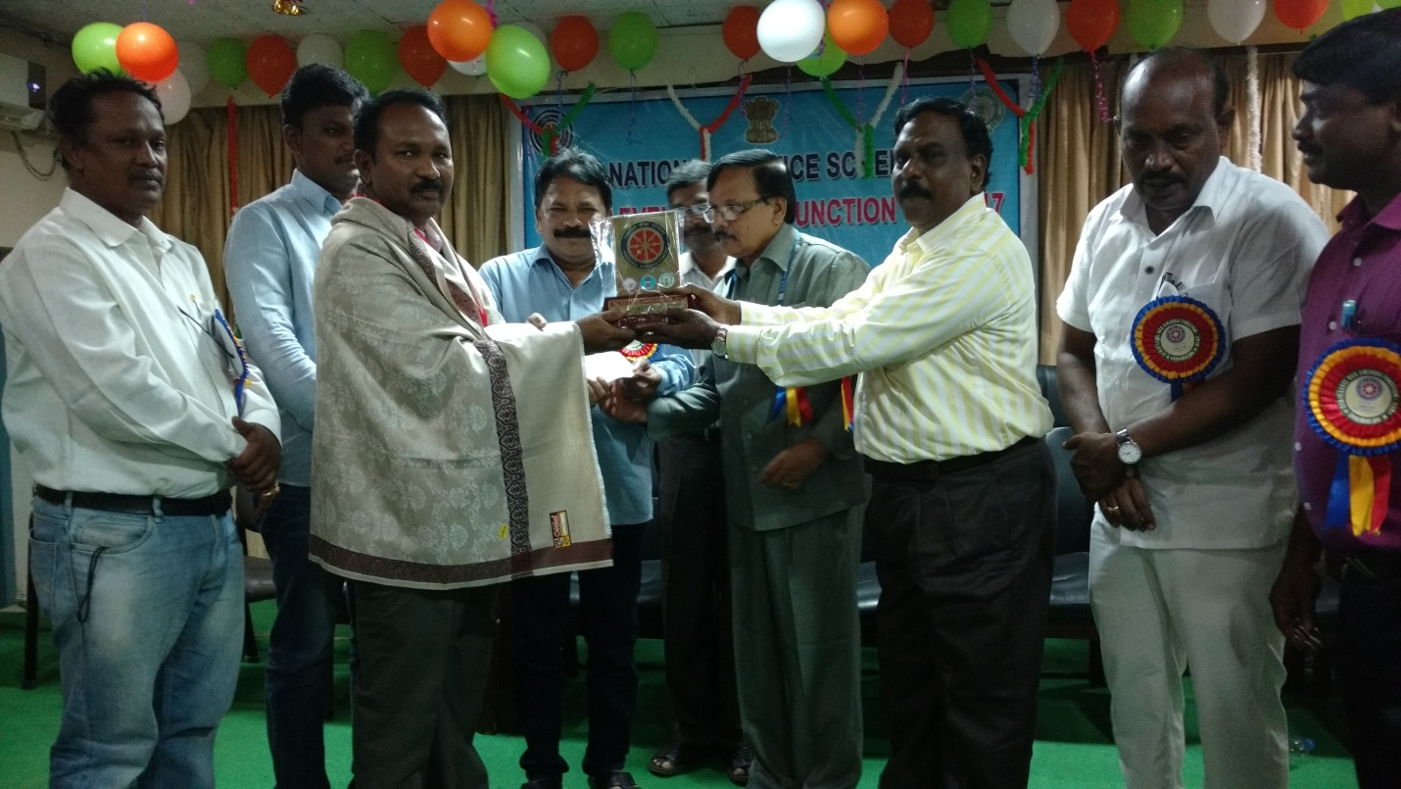

Prof. M.L.S.DEVA KUMAR NSS Programme Coordiantor JNTUA receiving STATE BEST NSS COORDINATOR Award

It is FIRST EVER such award for the University to receive.

