NATIONAL SERVICE SCHEME
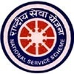
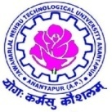
JAWAHARLAL NEHRU TECHNOLOGICAL UNIVERSITYANANTAPUR
ANANTAPUR – 515 002 (A.P) INDIA

JNTUA NSS RECEIVED INDIRA GANDHI NSS NATIONAL AWARD FROM THE HON’BLE PRESIDENT OF INDIA

J.N.T.U.A. Ananthapuramu got the prestigious award “Indira Gandhi National Service Scheme Award – 2015-16, which is conferred by Hon’ble President of India Shri. Pranab Mukharji on 19/11/2016 at Durbar Hall of Rastrapathi Bhavan, New Delhi. 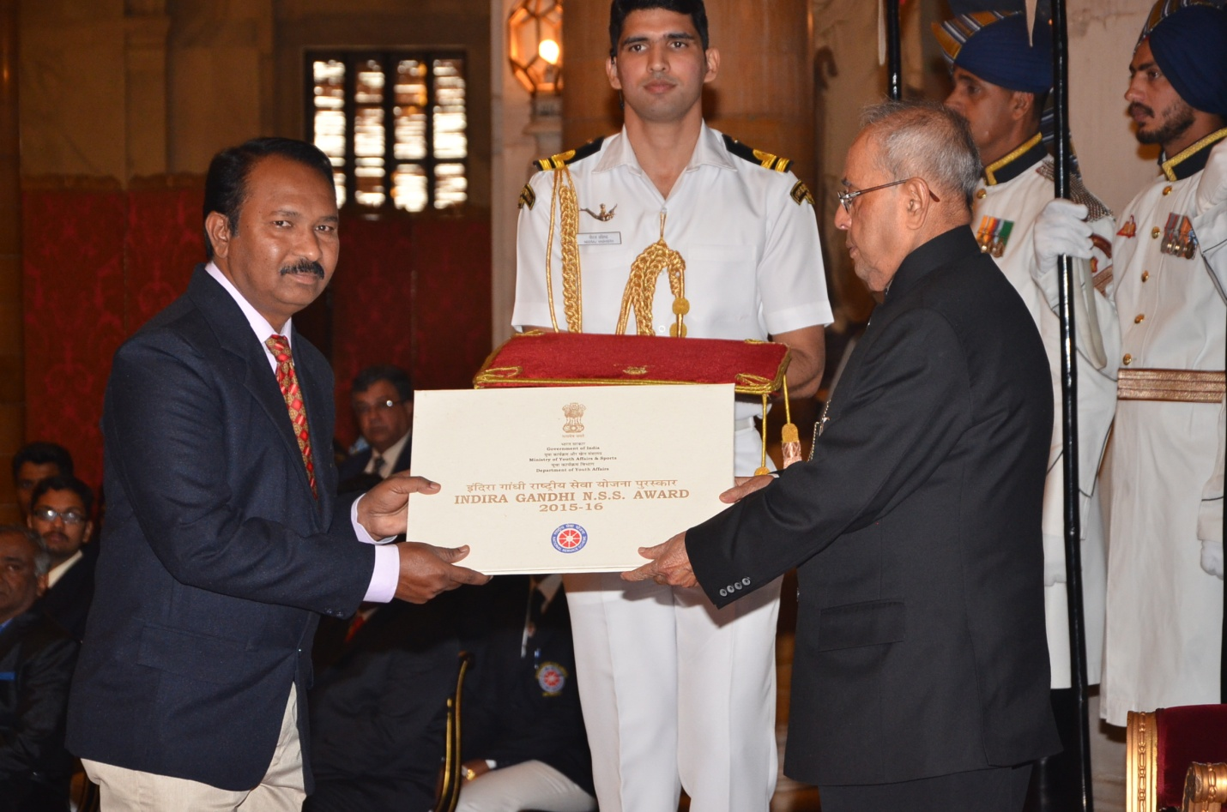
Prof. M.L.S.DEVA KUMAR NSS Programme Coordiantor JNTUA receiving IG NSS Award from
The President of India Shri. Pranab Mukharji

The Ministry of Youth Affairs and Sports, Govt. Of India has instituted the Indira Gandhi National Service Scheme (IG NSS) Award to recognize the Voluntary Service rendered by NSS Volunteers, NSS Programme Officers/College Unit, NSS Programme Coordinators / University Cell. 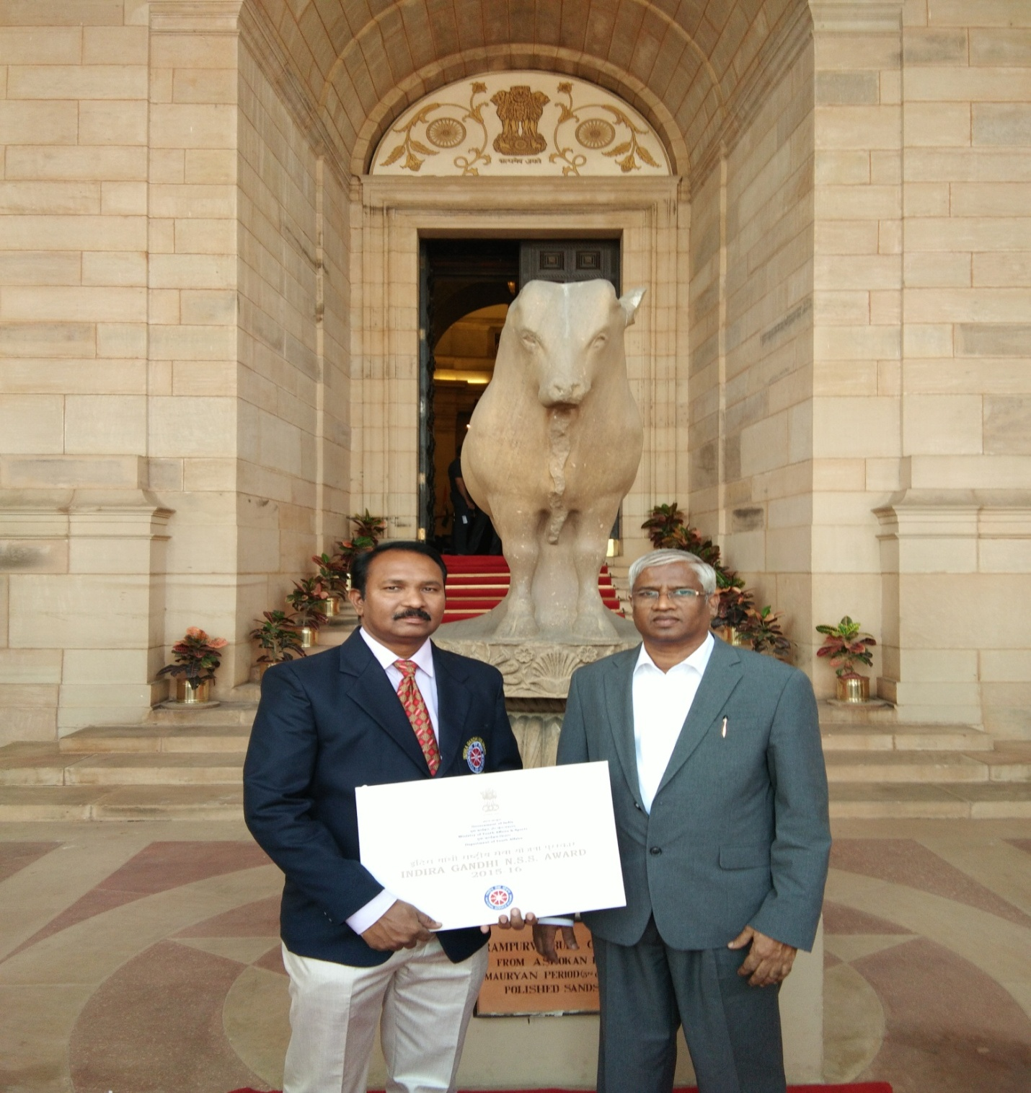
Hon'ble Vice Chancellor-JNTUA Prof. M.M.M.SARCAR and NSS PC Prof. M.L.S.Deva Kumar at Rashtrapathi Bhavan, New Delhi
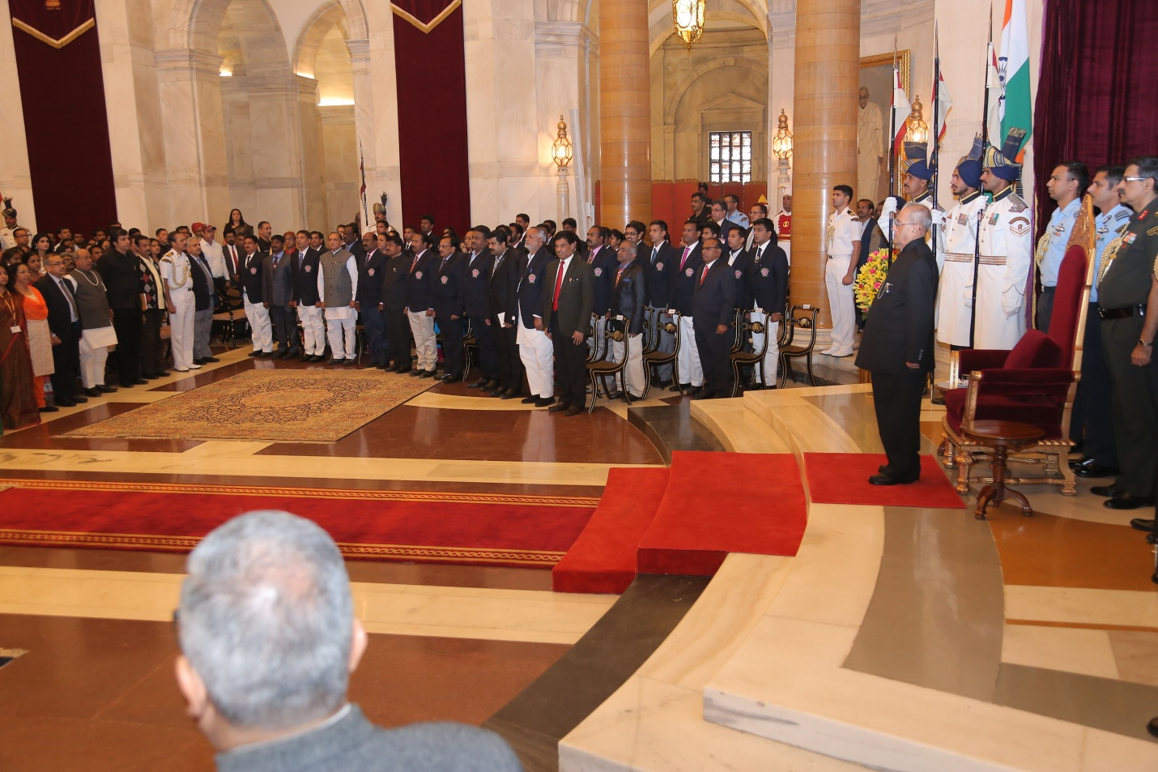
The Hon'ble President of India Shri Pranab Mukharji receiving ceremonial salute

These awards were instituted in the year 1993-94. Since then, these awards are given away every year at various levels. For the year 2015-16 under the category of Programme Coordinators / University, only FOUR Universities are selected for the award in the country. J.N.T.U.A. Ananthapuramu is one amongst the four of them.
The award “INDIRA GANDHI NATIONAL SERVICE SCHEME AWARD (Certificate of Appreciation) for the year 2015-16” is conferred on Prof. M.L.S.DEVA KUMAR, NSS Programme Coordinator of the J.N.T.U.A. Ananthapuramu by the Hon’ble President of India Shri. Pranab Mukharji, in the presence of Prof. M.M.M. SARCAR, Vice Chancellor of J.N.T.U.A. Ananthapuramu on 19th November, 2016 at Durbar Hall, Rashtrapathi Bhavan, New Delhi.

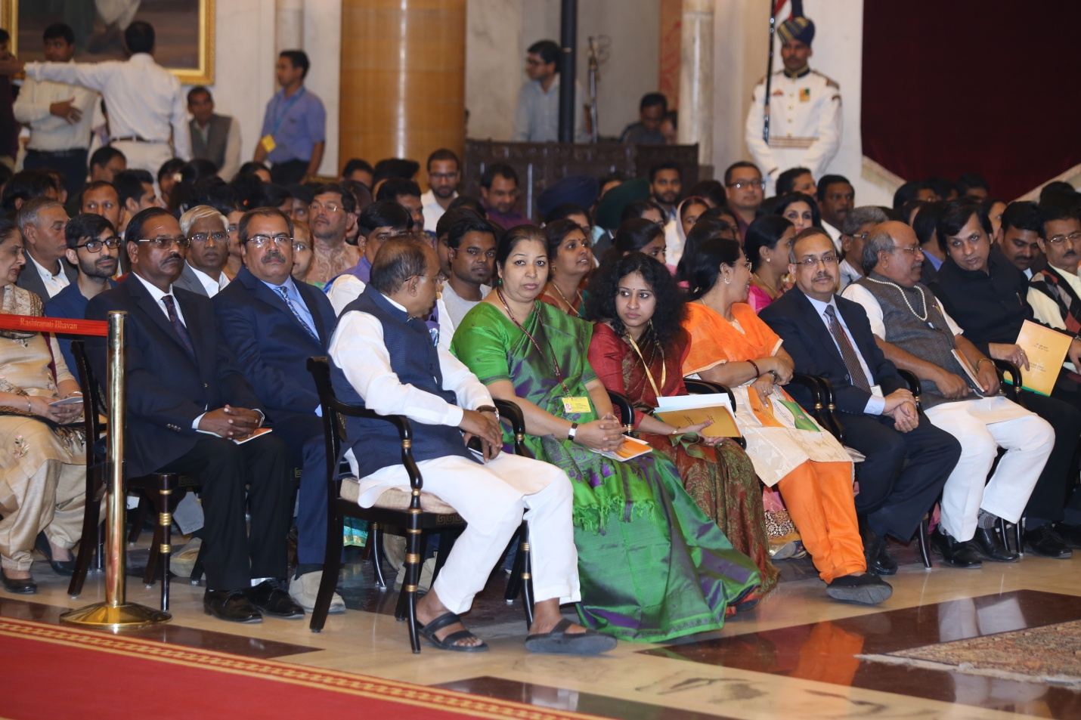
Union Minister of Youth Affairs and Sports Mr.Vijay Goyal, Prof. M.M.M.Sarcar VC-JNTUA, and Mr. Lakith Kumar Gupta, Joint Secretary MYAS, GOI in Durbar Hall of Rashtrapathi Bhavan

It is FIRST EVER such award for the University to receive from the Hon’ble President of India. In the state of Andhra Pradesh J.N.T.U.A. is second University to receive such award in the category of Programme Coordinator.
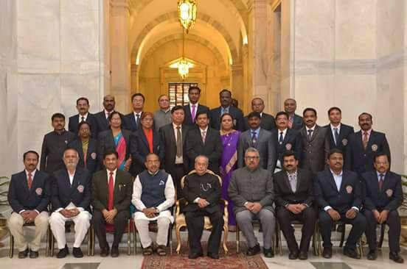
Group Photo of Awardees with The President of India, Union Minister, Secretary Ministry of Youth Affairs and Sports
NSS CELL, J.N.T.U.A conducted several programmes under the leadership of Prof. M.M.M.SARCAR Vice Chancellor and Chairman, NSS. Prof. M.L.S.Deva Kumar coordinated the events and activities. Few of the activities or events organised are presented below. J.N.T.UniversityAnantapur, Ananthapuramu leading by example towards ‘Sustainable Environment’ by establishing a NURSERY in the University Campus in association with Dept. of Forest, Govt. of A.P., where around 2 Lakh saplings are distributed for plantation in the surroundings of Anantapur.
- Constructed 5 FORMPONDS, in the University Campus in association with DWMA to preserve rain water.
- NSS Programme Coordinator Prof. M.L.S.Deva Kumar lead NSS AP Contingent at National Youth Festival, as AP CONTINGENT LEADER at Guwahati, Assam during 8th to 12th January, 2015, which is organized by Ministry of Youth Affairs & Sports, Govt. of India and Government of Assam.
- Conducted University Level Youth Festival at Kuppam Engineering College, Kuppam during 20th & 21st Jan, 2015.
- On Republic Day – 2015, the then Vice Chancellor Prof. K. Lalkishore presented NSS SwatchhaBharath – Janmabhoomi Awards for best maintained department and hostel. Swatch Bharath award gone to Dept. of ECE. Prof. M.N.Giri Prasad, HECED, JNTUACEA received it. This award carries Rs 25,000/-, Janmabhoomi Award gone to Shilpa Girls Hostel. OIH Dr. T.Narayana Reddy & Dr. Saila Kumari Dy. Warden received the award. This award carries Rs.20,000/- .
- Conducted MASS TREE PLANTATION in the JNTUA jusdiction on 6th Feb, 2015. On this day 3,750 plants were planted in various colleges.
- Organised STATE LEVEL NSS YOUTH FESTIVAL at JNTUA campus during 12th & 13th February, 2015. All the Universities in the State of Andhra Pradesh participated in the Youth Festival along with NSS Regional Director Shri. R.Gukulakrishnan, State NSS Officer Sri. Ramachanra Rao, Telagana State NSS Officer T.S.N.Reddy.
- Prof. M.L.S.Deva Kumar NSS Programme Coordinator acted as Resource Person at 7 Day Training of Spherehead Campaigners team of Youth Leaders on PUNARJAGARAN by Nehru Yuva Kendra at TTDC, Anantapur during 1st to 7th June, 2015.
- Conducted “International Day of Yoga” on 21st June, 2015.
- Conducted “Digital India Week” awareness programme and competitions on 2nd July, 2015.
- Conducted 4 week “Self Defence Training Programme for Girl Students” from 25th July to 21st Aug, 2015 jointly organized by NSS Cell & Women Empowerment Cell.
- Mr. K.P.RAMESH BABU of IV B.Tech ECE at JNTUACEA received “STATE BEST NSS VOLUNTEER” award from Dr. Kamineni Srinivasa Rao, Minister of Health & Medical Education. Govt. of A.P. at Dr. NTR University of Health Sciences, Vijayawada on 24th September, 2015.
- Conducted University Level YUVATHARANGAM competitions on 30th September, 2015.
- Conducted “Swatchha Bhrarath” and “Vanamahotsavam” on 2nd October, 2015 at JNTUA CAMPUS. 1000 plants were planted near new examination block.
- Three NSS Volunteers of JNTUA viz., Ms.P.Lavanya, SVCET, Chittoor., Mr.V.L.Prasanth, JNTUA College of Engineering, Anantapur., Mr.K.Chandramohan, JNTUA College of Engineering, Anantapurwere got selected and participated at West Zone NSS Pre-Republic Day Parade Camp – 2015 held at R.T.M.Nagpur University, Sports Ground, Amravati Road, Nagpur, Maharastra from 08-10-2015 to 17-10-2015.
- JNTUACEA NSS Unit-I Program officer Lt. S.Sharada selected as Contingent Leader and NSS Volunteers of JNTUACEA viz., P. Anusha,V.Brahmani,A.Rekha,P.LakshmiPrasanna,Samiyawere got selected and participated at National Adventure Camp – 2015 held at Atal Bihari Vajpayee Institute of Mounteneering and Allied Sports, Manali, Himachal Pradesh from 04-10-2015 to 13-10-2015.
- Conducted University Level Poerty Competition on Dr. A.P.J.Abdul Kalam. The winners are K.R.N.ASWINI (Aditya College, Madanapalli), SURESH (MERITS, Udayagiri), DAVID ALEXANDER (SRIT), M.SHAMEEM SULTANA (Ravindra, Kurnool), Prof. E.KESHAVA REDDY (JNTUACEA), Smt.H.RAJESWARI (JNTUA), Dr. THULASI KRISHNA. K. (MITS), M.M.IQBAL (Bhima, Adoni), K.GIRIJA KALYANI (JNTUA).
- Birthday of Dr. A.P.J.Abdul Kalam is celebrated on 15th October, 2015 and NSS Literary & cultural club organized a programme “Share a Dream – Share a Poem – Pay Tributes to Kalam”.
- Conducted National Unity Day on 31st October, 2015.
- At JNTUA campus EVERY THURSDAY from 4:00 p.m. to 6:00 p.m. SwachaaBharath – Janmabhoomi Cleaning Programme is being organized.

- Mr.K.Chandramohan, NSS Volunteer of JNTUA College of Engineering, Anantapur got selected and participated at Republic Day Parade Camp from 01-01-2016 to 27-01-2016 at New Delhi and he participated in Republic Day Parade on 26th January, 2016 at RedFort, New Delhi.

- JNTUA NSS songs Audio CD is produced with the talents of NSS volunteers, in which songs on patriotism, Environmental Protection, Social Service are covered. Some of the songs are written by students of the University.

- Conducted SHORT FILM festival, where several short films are produced by the University on themes like Swachha Bharath – Swachha Andhra, Greenery a panacea, Environmental Protection, Communal Harmony, Digital India etc.,

- Started an YOUTUBE CHANNEL ‘JNTUA NSS – YOUTUBE CHANNEL’, where selected short films and youth festivals and other useful videos are being uploaded for every body’s usage.

During the period it is organized 286 tree plantation programmes in which 1,21,300 saplings were planted. The NSS units under the jurisdiction of the University organised 221 blood donation camps in which 21691 units of blood were donated by the NSS volunteers; 495 health programmes including total health check up, eye camps, immunization camps and awareness programmes, campaigns and rallies.
THE CREDIT GOES TO ALL THE MEMBERS OF “TEAM NSS-JNTUA”
“Let us Join Hands – for Better Society”

