NATIONAL SERVICE SCHEME
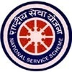
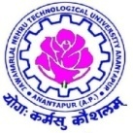
JAWAHARLAL NEHRU TECHNOLOGICAL UNIVERSITYANANTAPUR
ANANTAPUR – 515 002 (A.P) INDIA

REPORT ON ONEDAY WORKSHOP ON DROUGHT PROOFING
Conducted by
Govt. of Andhra Pradhesh :: Water Resources Department

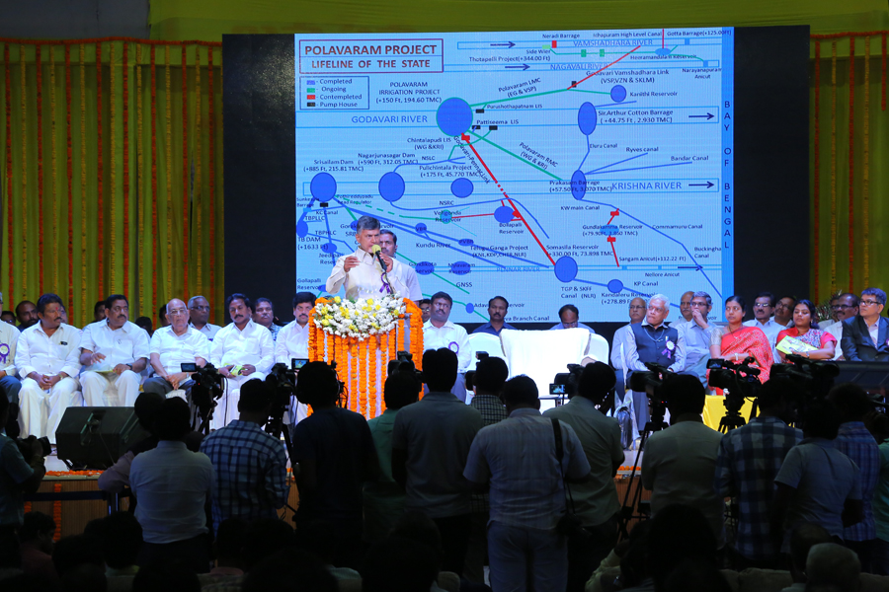
Water Resources Department, Govt. of Andhra Pradesh has conducted a One Day Workshop on Drought Proofing Andhra Pradesh on 8th April, 2017 at Thummalapalli Kalakshethram, Vijayawada. This one day workshop conducted on "Neeru-Pragathi" is to discuss the subjects such as Drought Proofing, Inter-liking of Rivers, Tank Cascades, Ground Water Recharge and construction of series of Check Dams by inviting all the Vice Chancellors, Principals, HoDs, Professors and Expert Academicians of all Engineering Colleges to offer their innovative ideas for effective conservation of water and its better management such that there should not be any drought in the State in coming years.
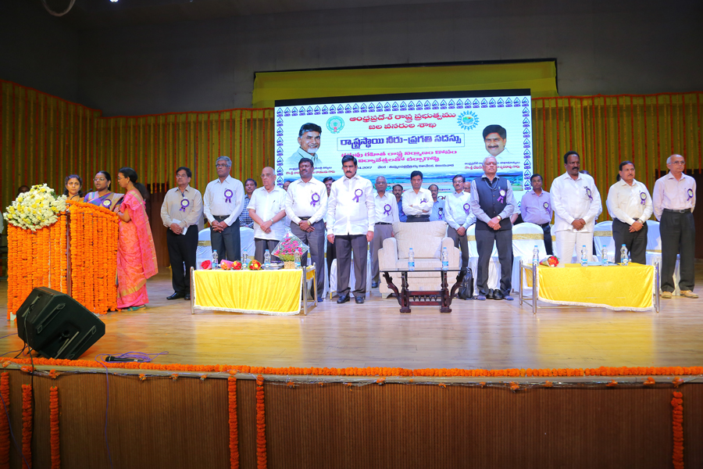
The workshop graced by Hon'ble Chief Minister Sri. N.Chandra Babu Naidu, Minister for Water Resources Sri. Devineni Umamaheswara Rao, Engineer In Chief - Water Resources, Dy. Director, Chief Engineers, Vice Chancellors, Principals, Professors, Students, Village Water Associations Presidents.
ENC Ravikumar explained the need of this workshop as there is 28 % shortage of rain fall compared to average annual rain fall in the state, which may lead to severe shortage of drinking water and water for irrigation. Requested for innovative ideas from all stakeholders especially from Universities and Expert members.
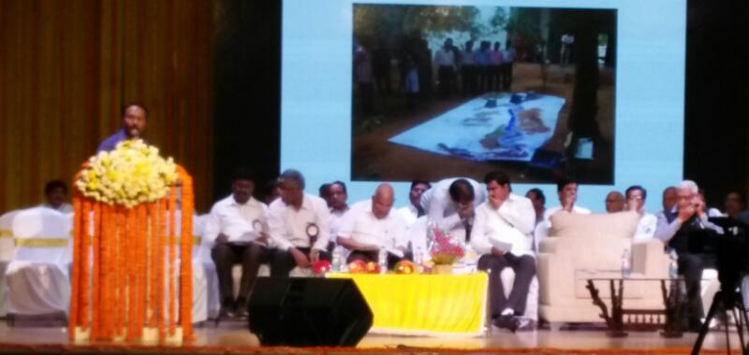
CE Sabjanvali explained about 7 missions, 5 Grids and 5 Campaigns of Govt. of A.P. to make Andhra Pradesh Sunrise State. Among them first one is "NEERU CHETTU". The two major aspects of the mission are Water Conservation, Water Management. It contain various targets viz., Drought proof state, Water Conservation, Goundwater recharge, Water Management, Water Budgeting, Modernization of Irrigation systems, Completion of Irrigation Projects, Inter-linking of rivers, Deeloping the Tank Cascades, Desilting, renovation and repairs to the tanks, feeder channels, supply channels, Repairs to the existing RWHS and Construction of New RWHS.
Krishna University Vice Chancellor Prof. S.Ramakrishna Rao explained about origin of water in the Universe, change in per capita requirement of water from 5000 lt to present 1400 lt. As water is elixir of life, he advised to create artificial wet lands, to used solar distillation for future use.
Mr. Ramanjaneyulu IAS, Commissioner-Rural Development, narrated agony of house wifes, farmers, a son of farmer, and of many people for water in rural and urban areas. He advised every man has to contribute for the water conservation. He quoted various schemes of Govt. of A.P. under Rural Development contributing for the water conservation.
Mr. Devineni Umamaheshwara Rao Minister for Water Resources, explained about various steps taken by Water Resources Department to improve the situation of the farmers. He quoted the committed efforts of Hon'ble Chief Minister in Polavaram Project and Patti Seem Project which are boon to the state. He advised all the farmers to utilize the schemes of Govt to improve the water availability. He introduced an app "VARUNA" as best online resource for every citizen.
Prof. M.L.S.Deva Kumar, NSS Programme Coordinator & Vice Principal, J.N.T.University Anantapur presented profile of Anantapur Dist as second lowest rainfall district in the country with 381 mm avg rain fall, with huge shortage of water requirement. He explained the challenges of University due to shortage of water and activities undertook at University Campus like Water harvesting pits, Farm Ponds, Plantation, Plantation Survival programmes, Campus Nursery, Desilting of Check dams etc., He explained the contribution of NSS volunteers in organising awareness programmes, producing short films, releasing Audio CD with theme of Water conservation, enviromental protection etc., He requested the Minister to relax certain norms like extending drip irrigation subsidy only to farmers but not for institutions, Min 500 m Hydraulic clearance for checkdams, Min 5 Acres land for sanctioning Farm Ponds etc., Minister instructed the concerned officers to look in to these issues.
Prof. KVSG Murali Krishna Principal Narasarao pet Engineering College explained about environmental impact and climatic changes on water resources. He advised every man need to contribute for the water conservation.
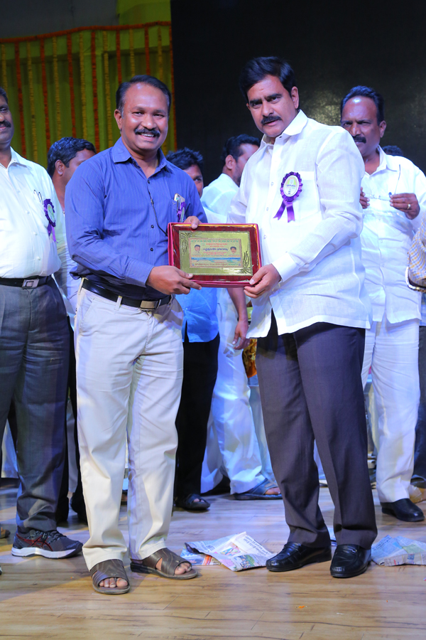Prof. Bhaskar, Rector, SV University, Tirupathi explained about various activities taken up by the University towards plantation and water cosnervation. He applauded the contribution of NSS volunteers in this aspect.
Dr. Kiran Kumar, Associate Professor in Civil Engg., KSRM College of Engineering, Kadapa has given lecture on water resources and technical features of ground water.
Dr. Sridhar, Vishnu Engineering College advised to utilise GIS Technology in identifying the water bodies.
Mr. P.Lakshmi Prasad explained about VARUNA app and he demonstrated the application of the app to know about all the details about water availability, ground water levels, temperatures, feellike temperatures, humidity of each and every mandal in the state of Andhra Pradesh in perpetual basis.
One of DFO narrated the need of the plantation to conserve the water.
Dr. S.Vijaya Kumar, Sr Scientist National Institute of Hydraulogy, Kakinada narrated how technical data is made possible to give correct data by using ISRO satellites inputs.
Mr. Naveen Reddy from KPMG-a Global Advisory Firm for AP on project management explained about salient features of a typical project.
Mr. Nageswara Rao Sr. Scientist, AP Space Application Centre, Vijayawada explained the process of identifying place for building check dams etc., by using the technology.
Mr. Rehman Rtd. ENC, explained about Govt. projects and problems and challenges and fruits of the projects.
Mr. P.N.Rao explained about water conservation projects in the state.
Mr. Rajagopala Rao, PD - DWMA, Krishna Dist explained about various schemes available to the people to conserve water at every household.
Mr. Naveen Asst. Professor, advised that everyone need to take responsibility of water conservation.
Mr. Malik Basha - II B.Tech CSE -BITS, Kurnool presented about app developed by him 'Kisan Darshan', which is having all videos are available to train the farmers from sowing to marketing of crops.
Hon'ble Chief Minister Sri. N. Chandra Babu Naidu narrated the need of the water to domestic, irrigation and industrial usage. The problem of water scarcity and reasons for the same are discussed. He quoted various schemes of the Govt. under Neeru-chettu and Neeru-Pragathi programmes. He has given target of maintaining ground water level in the state in between 3 m to 8 m. He advised the Govt. functionary to clean all ponds, cascade all ponds, cross cascadeing, using ISRO satellite mapping, to use DRONE technology for surveying and monitoring the water conservation activities.
Every University should give the task of developing innovative ideas and technological solutions and the task of water management to the students, where students should work in the field to gain practical exposure. He has stated that, every Engineering College will be assigned with few villages, where students need to takeup and monitor Soil Moisture Conservation activities. They need to conduct water audit with frequent visit to the adopted villages.
He narrated the Inter-linking of rivers Godavari, Krishna and subsequently Penna is the priority of the Govt. He anounced that, ground water recharge by aqua fed recharging, by constructing 19000 checkdams in near future. Students may need to supervise these actvities.
Before rainy season, we need to construct the structures for water conservation, he reiterated.
The programme closed with felicitating the Chief Minister, Minister and presenting mementoes to all the speakers and to the dignitaries on the dais.

